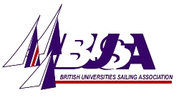APPLICATION FOR THE BUSA COMMITTEE 2014-15

Name
Photo
(please insert or attach)
University, current year of study and anticipated graduation date

Position interested in
Phone number
E-mail address
Experience: (Why would you be a great committee member? What sailing, committee and leadership experience do you have? - see role descriptions) No more than 200 words.
Proposer/University
Seconder/University

Will you be attending the AGM? (15th April, Portsmouth) YES NO

Deadline for applications: 4pm 28st March, 2014

