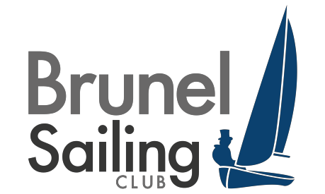

- Timings
Brunel Badger 2019
25th January - 26st January 2020 Datchet Water Sailing Club, Queen Mother Reservoir

Notice of Race

Saturday registration 0900 briefing 10:00 first warning signal 11:00 Sunday first warning signal 11:00

- Rules

  - Racing will be governed by the rules as defined in the Racing Rules of Sailing (RRS) including appendix D, Team Racing Rules.
  - The UK Team Racing Association Team Racing Sailing Instructions will apply. These change some rules in the RRS; they are available on the UKTRA web site (www.teamracing.org) and at registration.
  - All races will be umpired and an umpire’s decision is final. The Call Book for Team Racing will apply.
  - In accordance with rule 70.5(a) the right of appeal will be denied.

- Personal flotation devices and clothing

  - All competitors shall wear an adequate personal flotation device, and a dry suit or wet suit at all times when afloat.

- Acknowledgement of Risk

  - A boat is entirely responsible for her own safety, whether afloat or ashore, and nothing, whether in the Notice of Race or Sailing Instructions or anywhere else, reduces this responsibility.
  - It is for a boat to decide whether she is fit to sail in the conditions in which she may find herself. By going afloat, the boat confirms that she is fit for those conditions and that her crew is competent to sail and compete in them.
  - Nothing done by the organisers can reduce the responsibility of the boat nor will it make the organisers responsible for any loss, damage, death or personal injury, however it may have occurred, as a result of the boat taking part in the racing. The organisers encompass everyone helping to run the event, and include the organising authority, the Race Committee, umpires, patrol boats and beach masters.
  - The provision of patrol boats does not relieve the boat of her responsibilities.

- Prizes

  - Prizes will be awarded at the discretion of the organising authority.

- Entry and eligibility

- Entry is invited from RYA-affiliated clubs, class associations and other organisations that are affiliated to an organisation that is affiliated to the RYA.
- All three helms must be members of the affiliated club or association they represent.
- No individual may sail for more than one team. After an entry has been accepted, the nominated helms shall not be changed without the prior written approval of the Race Committee.
- Spaces are limited; teams will be accepted in the order of received entry fees and damage deposits.

- Entry fees and damage deposits

- The first entry from a club is £250 and subsequent entries are £150. Damage deposits are a flat £200 per team.
- Two separate cheques (or one if entry fees are paid by bank transfer), payable to ‘Union of Brunel Students’ need to be received by the 5th January 2020 to guarantee entry. If you require accommodation, please contact badger@brunelsailing.com
- Each team will be liable for the cost of damage to boats, equipment and property up to a maximum of £200 per incident. A deposit for this amount will be required at registration before the team may sail. When a team is assessed as liable for damage, it shall restore the deposit to the original value in order to continue sailing. Damage attributed to competitors generally or to an unidentified team will be attributed equally between all teams. A team may apply to the protest committee to determine their responsibility for any damage. The deposit, or any remaining balance of the deposit, will be returned after the championship.

