Club Development Plan Template

Published Date: | 1st March 2020 | Written and Agreed by:
Action Review Date: | 1st October 2020
Plan Review Date: | 1st May 2021

This Development plan is a long term plan, which will outlast the tenure of many members of your university sailing club. In it you will develop a long term aim (a “dream vision”) and then create Key Goals which will build towards this dream goal. We recommend that this “dream vision” is created as a dialogue between members and nominated committee officials. We also recommend that this document is filled in collaboratively with the help of the BUSA area chair and Development officer and with the input of the University Sports Union in the finalised plan. This will help keep the plan achievable and manageable, but also improve the accountability of the club in keeping to this plan. For an example of the kinds of conversations which should be had around developing this plan please see: https://www.youtube.com/playlist?list=PLRR1I7QyaNCd8cYBCUlj6rA8HFOZMPyIg

Where are we now?

What is the current situation of the club? Use the SWOT analysis format given in the guide to this form. Consider:
- what you offer to members, participants, affiliated groups. (eg. Students, alumni, students union(or equivalent), other university clubs, local sailing clubs)
- membership numbers and whether these are on the up, in decline or steady, particularly over at least the last 5 years
- your volunteers and their numbers and skill sets (eg. Qualified instructors + coaches, committee members)
- your facilities and equipment
- your financial situation (this should be more than just X amount in bank, should include predicted income from different sources, running costs, how much you need to be saving to afford things in the future)
- who you work with – partnerships (local sailing clubs, students union, other university clubs etc)

The British Universities Sailing Association, like UK sailing generally is facing a number of different challenges with a change in the ways in which people are participating. Current membership of BUSA clubs stands at approximately 2500 members, distributed across the UK. It is currently unknown if these are changing, due to lack of data. Most clubs were between 31-60 members sized (22 clubs) and the average membership size was 51 members. Compared to the rest of the UK, BUSA clubs had greater gender parity in their memberships (54% men and 45% women compared to 63%:37% for the UK as a whole) and members were more active (66% compared to 37%). The most popular activities were team racing and social sailing, while other activities such as match racing were less well attended. Club memberships were largely composed of first-year and second-year undergraduates, while the main group of postgraduates participating were Masters students. Scottish and northern clubs are consistently underrepresented at all BUSA run events, which we primarily attribute to an increased expense and travel distance from many BUSA events. These clubs are also not likely to perform as well at Team Racing Finals across the sampling period. There were fewer female helms compared to male and for any yacht based event, there was also significantly more male crew than female. There were however, no changes in fleet racing in terms of female crew and there were actually more female crew at Team Racing Finals compared to male. This we attribute in part to clubs trying to “get around” existing gender balance requirements.

BUSA has no facilities, however member clubs run events on our behalf. Sponsorship agreement? ASf agreement?

Financial situation?

BUSA works collaboratively with the RYA, it’s members clubs, local affiliated sailing clubs and the Magenta project.
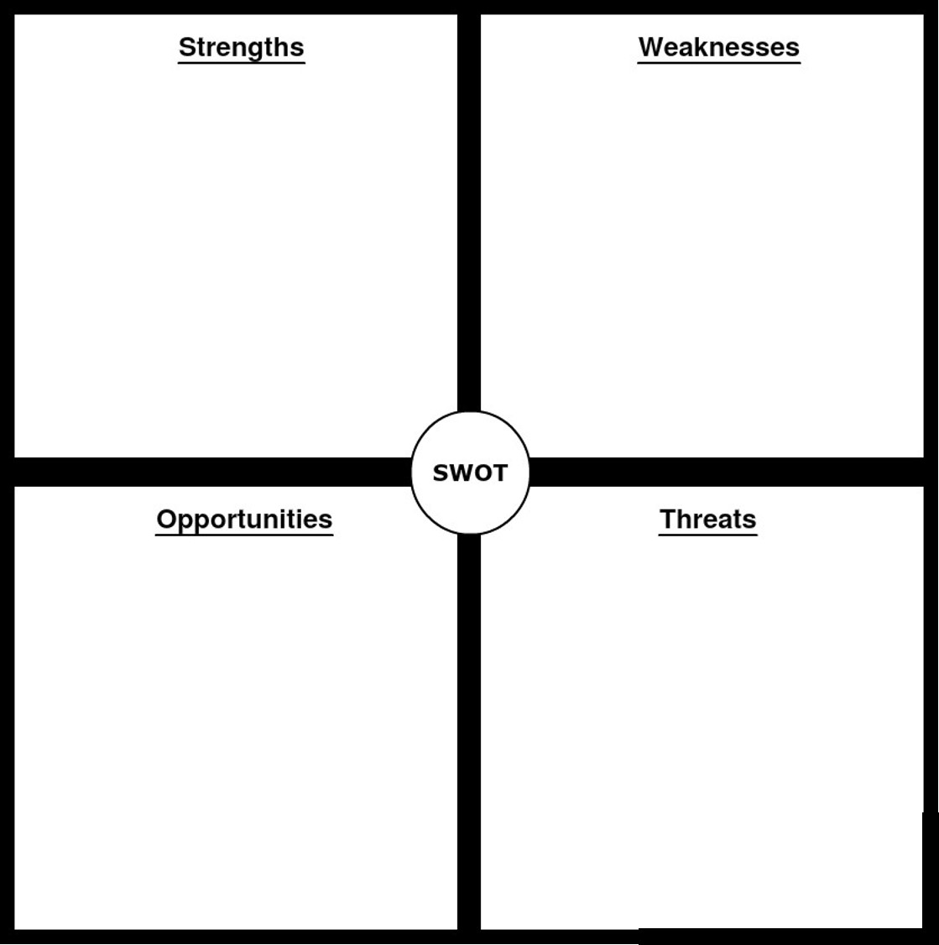
- Finances are a continuing issue going forwards.
- Rapid overturn of committee ensures a rapid circulation of fresh ideas.
- UK sailing is changing and BUSA is at the forefront of these changes.
- UK wide reach.
- More active membership compared to the UK average.
- More gender balanced club membership compared to the UK average.

- Committee turnover is rapid.
- Coordination between member clubs can be challenging.
- There is an existing strain upon the finances of BUSA.

Where do we want to be in 3-5 years time?
BUSA’s Vision

Participation
- Every UK university has a sailing club with boats and high quality equipment.
- More people involved in university sailing.
Equality
- Equal representation of each region.
- Equal representation of all disciplines, including social sailing and development opportunities.
- Affordable access to yacht sailing.
- Equality of opportunity: 50/50 gender split.
- Equality and diversity training for members.
Development
- Students leave university having improved their sailing as a student.
- Signposting sailors to further opportunities.
- Club development and funding support offered by BUSA
- Advice to engage alumni
- Proactively developing clubs
- BUSA Membership fees provide value for all clubs and all sailors, not just for racing.
Quality & Opportunity
- Vast array of high quality sailing events.
- International opportunities available to the best BUSA sailors beyond the Tour.
- Cooperation between regions.
BUSA Operations
- BUSA is clear and consistent in its operations.
- Communications concise and reach every sailor.
- Everyone knows what BUSA is, what it does, and who the Committee are.
- Awareness of BUSA among sailors pre-university: advertised at Youth sailing events.

Key goals for the next 3-5 years, to achieve this vision. These may need to happen now, next month, next year or even 2 -5 years time. For a breakdown of this, please see the guide.

- Equal representation of each region.
- Equal representation of all disciplines, including social sailing.
- Equality of opportunity: 50/50 gender split.
- Financial stability of BUSA
- Enhanced collaboration between BUSA, the RYA, member clubs and existing organisations aiming to achieve the above goals.

How will we get there?

Action Plan – what are the objectives you need to undertake? These should be looking to achieve your Key Goals (above) and may require more than one year to achieve. These should be SMART objectives (please see the guide).
Progress/Outcome Key | Legend
Not started, no action required
In progress and on track
In progress, some action required
Significant action required
Completed

Key Goal number 1: Equal representation of each region.

Objective  What does Key Goal Number 1 break down in to? | Actions | Resources | Lead / Supported by | Timescale and Deadline | Progress
- To achieve Key Goal number 1, what are the things you must do? | - What must the club management do to help achieve objective number 1? | - What do you have available to help you in this? | - Whom will be doing this? | - How long do you have to do it?
- Expand current regional committees | - Develop a regional committee in all the English regions.  - Recruit members to these committees  - Run these committees | - Draft a constitution template for use by area reps to recruit members. | - Development sub-committee  - Area reps | - September 2020
- Move more events further north | - Approach university and UK sailing clubs to host BUSA sailing events, such as Fleets and Team Racing. | - Existing BUSA network and the network of individual committee members. | - Area reps | - September 2020
- Monitor participation numbers at BUSA events | - Continue existing monitoring efforts  - Create and publish next 2019-2020 update on existing technical reports | - Technical reports “who is a BUSA member” and “who is participating in BUSA events”.  - Raw data from these technical reports. | - Development officer | - September 2020

Key goal number 2: Equal representation of all disciplines, including social sailing
Objective | Actions | Resources | Lead / Supported by | Timescale / Deadline | Progress
- Enhance social sailing provision | - Resource development  - Instructor training  - Increased number of social sailing events | - Existing resource bank  - RYA training  - ASF partnership | - Development officer  - Vice chair | - Ongoing  - Resource bank developed.  - Instructor training pending ASF partner confirmation  - Increased number of social sailing events next focus area.
- Enhanced yachting provision | - Understand available fleets for access by students.  - Promote the development of keelboat sailing events including cruising | - RYA  - ASF  - UK clubs  - Committee network | - Development officer | - Ongoing
- Increased number of student focussed fleet racing events | - Work with class associations to get more student entries to existing events  - Help individual universities develop their own fleet racing events | - Class associations  - University sailing clubs | - Development officer  - Area reps | - Ongoing

Key goal number 3: Equality of opportunity: 50/50 gender split.

Objective | Actions | Resources | Lead / Supported by | Timescale / Deadline | Progress
- Develop a diversity and equality policy to be implemented within BUSA. | - Write this policy | - World sailing trust women in sailing strategic review.  - New Zealand Women in sailing recommendations.  - RYA collaboration | - Development officer | - September 2020
- Support the development and retention for female coaches and instructors within BUSA | - Female led and targeted instructor training.  - General instructor and coach development including resources.  - Understand the causes of this “leaky pipeline” and develop measures to address the issue. | - The ASF partnership  - Magenta project contacts  - Academic contacts within sports development. | - Development officer  - Vice president | - Ongoing.  - Female instructor course promotion and magenta project collaboration.  - General coach and instructor resource development September 2020.  - Cause of the “leaky pipeline” ongoing alongside existing research efforts.
- Push to increase the proportion of female race officials | - Introduction to umpiring courses.  - Marklaying course access  - Race officer training access | - RYA training department | - Development officer | - Ongoing
- Increase the proportion of female helms | - Pilot mentoring program  - Pilot altered participation pathways  - Increase opportunities for female helms | - The ASF partnership  - Magenta project contacts  - RYA training department | - Everyone | - Ongoing

Key goal number 4: Financial stability of BUSA

Objective | Actions | Resources | Lead / Supported by | Timescale / Deadline | Progress

Key goal number 5: Enhanced collaboration between BUSA, the RYA, member clubs and existing organisations aiming to achieve the above goals.

Objective | Actions | Resources | Lead / Supported by | Timescale / Deadline | Progress

Key goal number 6:

Objective | Actions | Resources | Lead / Supported by | Timescale / Deadline | Progress

