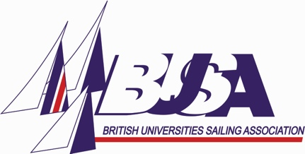
BUSA Administrator Application Form
Please complete this form fully and accurately and send to busacommittee@gmail.com when complete.

Data Protection
You agree to BUSA holding and processing, both electronically and manually, personal data about you (including sensitive personal data as defined in the General Data Protection Regulation (EU) 2016/679, the Data Protection Act 2018 and any national implementing laws, regulations and secondary legislation, as amended or updated from time to time, in the UK together with all other applicable data protection and privacy law) in accordance with the BUSA Privacy Policy, for the purpose of recruitment and selection and for the purpose of complying with applicable laws, regulations and procedures.
Eligibility:
By applying for the role you are stating that you are eligible to work in the UK and are willing to become self-employed. We are unable to apply for a Certificate of Sponsorship for this role.
Equality:
We are an equal opportunities organisation and are committed to safeguarding and promoting the welfare of children and adults.

Candidate details
Full Name
Home Address
Telephone number
Personal Email address

Personal Statement
Why do you want to work for BUSA and what do you have to offer?
Person Specification
Please work through the Person Specification (included with the advert) and explain how you meet the criteria. It is important to be very specific and clear, as this will be used to shortlist you for interview.
Employment experience (including voluntary work)
Please supply details of previous employment, including dates where possible.

Education & Qualifications
Please supply details of your education and any other relevant qualifications.
Referees
Please supply details of two referees, neither of whom are related to you and can comment on your suitability for the position. One should be relevant to the post.
 | Referee 1 | Referee 2
Name
Job title
Address
Telephone
Email
May we contact this person without further permission?

Declaration
I hereby give my consent for BUSA to process the data supplied in this application form for the purpose of recruitment and selection. I have read and understood the data protection, eligibility and equality statements stated at the top of the application form.

I declare that the information given in this application is to the best of my knowledge complete and correct.

Signature |  | Date

