Angel of the North 26th – 27th November 2022

SAILING INSTRUCTIONS

- Rules
- Racing will be governed by the rules as defined in the Racing Rules of Sailing (RRS) including Appendix D, Team Racing Rules.
- Addenda A, B and C to these sailing instructions (SIs) always apply. Other addenda apply only when so stated. The letters D and I are not used to identify addenda.
- The right of appeal is denied in accordance with RRS 70.5(a).
- When boats are provided by the Organising Authority
  - the boats shall be deemed to conform to their class rules;
  - when class rules change RRS 42, such changes shall not apply;
  - the race committee will allocate the boats to be used in each race; this allocation shall not be cause for redress and amends RRS 62.1.
- Eligibility
- To become eligible a team shall register as required by the notice of race or, if not specified, on arrival at the event. The team shall provide any required damage deposit before going afloat for the first time.
- After registration, no team member may be changed without the prior permission of the race committee which will be given only in exceptional circumstances.

3. Event Format and Schedule of Races
- The intended format of the event is described in SI Addendum B. The format may be modified during the event in a fair and practical way as solely determined by the race committee taking into account the entries, weather conditions, time constraints and any other relevant factors.
- The initial schedule of races will be displayed on the official notice board. Any changes thereto and schedules for subsequent races will be displayed not less than 10 minutes before the start of those races.
- Every race will be assigned a race number in the race schedule.
- The number of the next race to start will be displayed on the committee boat no later than the warning signal (or promptly thereafter if co-incident with the previous start) until the starting signal. The race committee may at any time postpone a race and reschedule it at a later time.
- When a completed race has been abandoned and the result would not affect which teams qualify for a further stage, the race committee may cancel the race and score each team half a race win.
- Protests, Requests for Redress and Penalties
- Protests and requests for redress that have not been decided afloat shall be notified to the race office within 10 minutes after the relevant incident or, if the incident is afloat, within 10 minutes after coming ashore.
- When the outcome of a protest or request for redress would not affect which teams qualify to a later stage, the protest committee may refuse to hear it. This amends RRS 63.1.
- When RRS D2 applies and the race umpires together with one other umpire (when available) decide that a boat has broken RRS 14 and there is damage or injury, they may penalise her team by half a race win without a hearing. The boat will be informed as soon as practical and may request a hearing. Any penalty after a hearing will be in accordance with RRS D3.1(d). This amends RRS 63.1.
- When the race committee decides that a boat has broken SI A4.3, Time Limit for Starting, or has failed to sail the course and broken RRS 28.2, it shall penalise her 6 points without a hearing. This amends RRS A5.
- When the race committee decides that a competitor has broken SI A1.5, personal flotation device, or SI A1.6, wet or dry suits, it shall penalise the competitor's team one race win without a hearing. This amends RRS A5.
- When the protest committee decides that a breach of a rule, other than a rule of RRS Part 2, has had no effect on the outcome of a race, it may make any arrangement it decides is equitable, which may be to impose no penalty. This amends RRS 64.1 and D3.1.
- Risk Statement, Insurance
- Rule 4 of the Racing Rules of Sailing states: "The responsibility for a boat’s decision to participate in a race or to continue racing is hers alone."
Sailing is by its nature an unpredictable sport and therefore inherently involves an element of risk. By taking part in the event, each competitor agrees and acknowledges that:
(a) They are aware of the inherent element of risk involved in the sport and accept responsibility for the exposure of themselves, their crew and their boat to such inherent risk whilst taking part in the event;
(b) They are responsible for the safety of themselves, their crew, their boat and their other property whether afloat or ashore;
(c) They accept responsibility for any injury, damage or loss to the extent caused by their own actions or omissions;
(d) Their boat is in good order, equipped to sail in the event and they are fit to participate;
(e) The provision of a race management team, patrol boats and other officials and volunteers by the event organiser does not relieve them of their own responsibilities;

(f) The provision of patrol boat cover is limited to such assistance, particularly in extreme weather conditions, as can be practically provided in the circumstances; and

(g) It is their responsibility to familiarise themselves with any risks specific to this venue or this event drawn to their attention in any rules and information produced for the venue or event and to attend any safety briefing held for the event.
5.2 When the boats are provided by the competitors, the boat is required to hold adequate insurance and in particular to hold insurance against third party claims in the sum of at least three million pounds (£3,000,000), unless a different sum is specified in the notice of race.

Index to SI Addenda
Not all addenda will apply to every event; see SIs 1.2 and A5.1.

Addenda That Always Apply
A Event Related Rules
B Event Format
C Courses
Race Formats and Schedules
E Round-Robins in Groups, Schedules and Tie Breaks
F Random Pairs, Schedules and Tie Breaks
G Swiss League, Schedules and Tie Breaks
H HLS League, Schedules and Tie Breaks
J Special Event Format (provided by race committee)
Other Addenda
K When Boats are Supplied by the Organising Authority
L Boat Handling Rules (intended for keelboats)

Addendum A - Event Related Rules

Event:

Section 1: Additional Rules Delete as required
A1.1 RRS D2 applies. Races will be umpired. | Yes
A1.2 RRS D1.1(d) is deleted. No Arm Signals are required. | Yes
A1.3 (1) A boat capsized after her starting signal, so that her masthead is in the water, shall retire promptly. | Yes
A1.4 Provided the flag remains on the buoy there shall be no penalty when a boat touches any part of a flag which does not surround the staff of a mark. This amends RRS 44.1. | Yes
A1.5 An adequate personal flotation device shall be worn at all times whilst afloat. | Yes
A1.6 Wet or dry suits shall be worn at all times when afloat. | Yes

Section 2: Communications with Competitors
A2.1 Notices to Competitors
Notices to competitors will be posted on the official notice board located in the clubhouse used for the event.
A2.2 Changes to Sailing Instructions
Changes to these SIs will be signalled by flying flag L from Club flagpole. Such changes will be posted on the official notice board not less than 10 minutes before the warning signal of the first affected race.
A2.3 Signals Made Ashore
Signals made ashore will be displayed on the Club flagpole.

Section 3: Courses, Marks, Starting & Finishing Lines, Obstructions and Time Limits
A3.1 Racing Area
The racing area will be approximately 250m south of the clubhouse
A3.2 Course
The course will be course C1 as described in SI Addendum C.
A3.3 Marks
The marks of the course will be round spherical buoys, wither bright pink or white in colour
A3.4 Moving Marks
The race committee may move marks of the course at any time. RRS 33 will not apply.
A3.5 Obstructions
The following areas are defined as obstructions: the far west of the reservoir as it gets very shallow and top north east of the reservoir as again it is very shallow.
A3.6 Starting Line
The starting line will be between the mast of a committee boat and a starting mark.

A3.7 Finishing Line
The finishing line will be between the mast of a committee boat and a finishing mark.

A3.8 Time Limits
The time limit for each race shall be 30 minutes.

Section 4: Starting Procedure
A4.1 Starting Signals
Races will be started by using the signals and timing selected in the following table. Times shall be taken from the start of each sound signal; the failure of a visual signal shall be disregarded. This amends RRS 26.

Mark '✓ ' in the top row, one column for timing and one column for visual signals
Event System | ✓ |  |  |  |  | ✓
Signal | Timing options |  | Sound | Visual signal options
 | Minutes before starting signal |  |  | Flags | Cone & Ball Shapes | Battens or orange cylinders
Warning | 3 | 5 | One | Class flag up | Cone shape up | 3 displayed
Preparatory | 2 | 4 | One | Flag P up | Ball shape up | 2 displayed
One-minute | 1 | 1 | One | Flag P down | Ball shape down | 1 displayed
Starting | 0 | 0 | One | Class flag down | Cone shape down | None

However, when the starting signal is also the warning signal for the next race, the class flag or cone shape will remain displayed, or 3 battens or cylinders will be displayed.
Attention may be drawn to an imminent warning signal by a series of short sound signals.

A4.2 Recall Signals
When a boat is subject to RRS 29.1, flag X need not be displayed for more than 1 minute after the starting signal; this amends RRS 29.1. The race committee may hail the sail numbers or the total number of premature starters.

A4.3 Time Limit for Starting
A boat shall not start more than 2 minutes after her starting signal.

A4.4 General Recall
After a general recall, succeeding races may be delayed for the recalled race. Attention is drawn to SI 3.4.

Section 5: Local and Other Rules
A5.1 Rules in SI Addenda
The rules in the following SI addenda apply throughout the event:

Addendum K | When Boats are Supplied by the Organising Authority | Yes
Addendum L | Boat Handling Rules | Yes

Addendum B - Event Format

The format for each stage of the event shall be selected from the following standard formats, or from an Addendum J provided by the race committee and included with these sailing instructions. The specified addendum for each format contains the necessary race schedules, or procedures to create the schedules, together with rules which shall apply for scoring and breaking ties.

Each stage of an event may use a different format. The race committee may change the format as provided in SI 3.1.

Code | Description | Format Rules
Groups | Round-robin(s) in group(s) | RRS D4 and  Addendum E
Random | Random pairs (2-boat teams only) | Addendum F
Swiss | Swiss league | Addendum G
HLS | HLS league | Addendum H
RC | Other format provided by race committee | Addendum J
KO | Knock-out | RRS D4

For each stage, any assignment of teams to groups or matches and the method of qualification for the next stage shall be stated.

For a round-robin stage, the number of round-robins in the stage, any carry-forward and weighting applied of scores from an earlier stage and any change to the percentage in RRS D4.2(b) shall be stated.

For a Knock-Out stage, the number of race wins required to win a match shall be stated, as RRS D4.6. However, if not stated the winner shall be the first team to score two race wins.

The intended format is

Stage | Format Code | Additional Information
1 | HLS | Top four teams progress to stage 2
2 | KO | Semi-finals, 1st v 4th & 2nd v 3rd first to score 2 race wins progresses to stage 3
3 | KO | Final, first to score 2 race wins

Addendum C - Courses
C1 'S' Course
This is the standard team racing course for multi-team dinghy events. In most conditions it enables rolling starts at 3 minute intervals.
Start, round marks 1 then 2 to starboard, round marks 3 then 4 to port, Finish
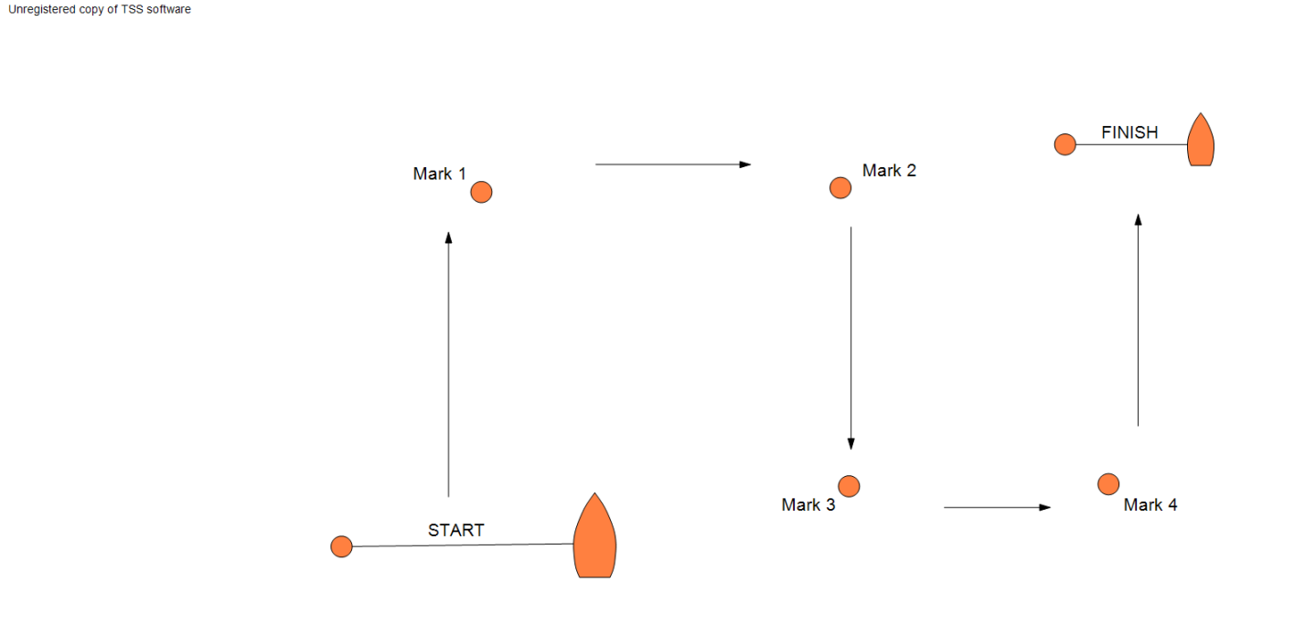
C2 Rectangular Course
If rolling starts are required, separate start and finishing lines should be laid.

Start, round marks 1, 2, 3 and 4 in order, then cross the start/finish line.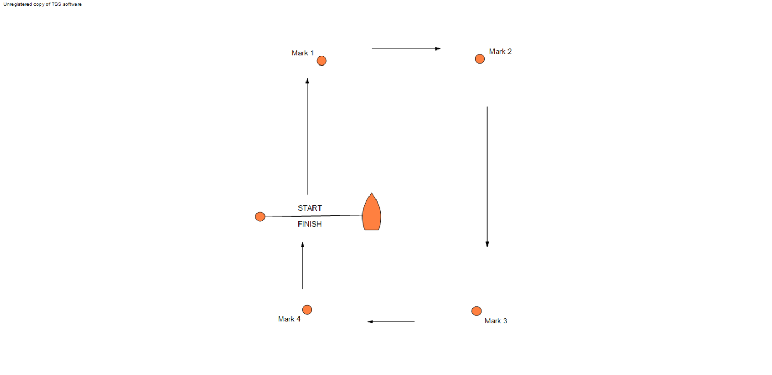

Round all marks to: Port / Starboard

Number of laps: 1 / 2 / 3 / 4
OR
As shown on the committee boat.

C3 Other Course

As displayed on the official notice board.

Addendum E - Round Robins in Groups

E1 In a round-robin stage, teams are assigned to one or more groups and scheduled to sail against all other teams in their group one or more times.

E2 In the first stage of an event, the teams may be assigned to a single group, seeded to groups based on past performance or assigned randomly. In subsequent round-robin stages the highest placed teams will be assigned to one group, the next highest placed teams to another group, and so on.

E3 The stage shall be scored in accordance with RRS D4.1 to D4.5 inclusive. However, results from the previous stage may be carried forward and the scores from the previous and current stages may be given different weights.

Addendum F - Random Pairs

F1 In this stage boats are scored individually while competing as part of a team.

F2 In each race of this stage boats will be randomly assigned to race in a team with another boat against another team of randomly allocated boats. No two boats will be assigned to the same team more than once.

F3 During this stage, the following rules will apply:

F3.1 Each boat in the winning team of each race shall be scored one race win. Each boat in the losing team shall be scored zero race wins.

F3.2 Boats shall be ranked in order of number of race wins, highest number first. If the boats have not completed an equal number of races, they shall be ranked in order of the percentage of races won

F3.3 Ties will be broken using RRS D4.4 amended as follows (changes in bold)

Ties shall be broken using only the results in the stage, in order,
- the highest number of race wins in all races between the tied boats;
- the lowest total team points scored in all races between the tied boats;
- if two boats remain tied, the winner of the last race between them;
- the lowest average team points scored in all races against common teams of opponents;
- a sail-off if possible, otherwise a game of chance.
If a tie is partially broken by one of these, the remaining tie shall be broken by starting again at step (a) above.

Addendum G - Swiss League

G1 This stage will be a computer-generated Swiss League.
G2 A draw will determine the first round.
G3 The second round will be using the order of the original draw, the first winner against the second winner and so on, except the first loser will sail the last loser or the last winner.
G4 Rounds will then be scheduled at the conclusion of a round for the next round but one by ordering the teams, using the tie-breakers below, and then matching them as far as possible in order of their places (the first team will sail the second team and so on), except that teams will not be matched if they have met within the number of rounds given above.
G5 If the final round cannot be completed, its results will be ignored.
G6 Races that cannot be sailed in order, or for which results are not entered or complete, will be ignored for scheduling purposes. Subsequently corrected or altered results will not affect a published schedule.
G7 A drop-out is a team unlikely, in the opinion of the race committee, to take any further part in the event. The decision to designate a team as a drop-out will be posted, after which its races will continue to be scheduled but will not be sailed and opponents will score a win. Drop-outs will be scheduled from the first unscheduled round after dropping out, first against each other and then, where possible, against the lowest-placed team it has not met. Drop-outs may re-join the event at the discretion of the race committee whose decision will be final.
G8 Any other missing team is a no-show and the opposing team will be given a walk-over after at least one of its boats has started and sailed for two minutes.
G9 Resails will be sailed at the end of the next available round. The race committee will allocate the resails within a slot and they will not necessarily be in the same boats as the original race.
G10 Half-win penalties will be applied after the end of the round and before tie-breakers are applied.

Rules for Breaking Ties
G11 RRS D4.4 is changed to
Ties will be broken, in order of precedence, in favour of the team(s) that has
- if the tie is between two teams only, won the last race between them.
- sailed more races against teams that have a higher place.
- sailed fewer races against teams that have a lower place.
- the lowest sum of the places of the teams the tied teams have beaten.
- the lowest sum of the places of the teams to which the tied teams have lost.
- beaten the highest-placed team the tied teams have individually beaten.
- not been beaten by the lowest-placed team to which the tied teams have individually lost.
Step (a) will be applied whenever a step leaves a tie between two teams. Steps (b) to (g) will be repeated until no more ties can be broken. Any remaining ties will then be broken:
- by the draw for the first round; ties in odd-numbered rounds will use the draw, ties in even-numbered rounds will use the draw inverted.

Addendum H - HLS League

H1 Teams for each race will be selected randomly. Teams will not sail any other team more than once in stage 1.

Rules for this stage

H2 If the full round robin has been completed, teams will be ranked on the basis of RRS D4.3 and ties broken using RRS D4.4. RRS D4.2(b) does not apply to stage 1.

H3 If the full stage has not been completed, teams will be ranked in order of their percentages of races won. Any ties shall be broken in accordance with the following rules and RRS D4 is changed accordingly. Ties shall be broken in the following order in favour of:
- If all tied teams have met, the number of races won when the tied teams met.
- If all tied teams have met, the points scored when the tied teams met.
- The sum of points scored in all races divided by the number of races sailed.
- For each tied team, the sum of the percentages of races won by the teams they beat, calculated as H3 above, divided by the number of races they won.
- For each tied team, the sum of the average points per race for the teams they beat, divided by the number of races they won.
- A sail-off if possible, otherwise a game of chance.

H4 In H3(b), H3(c) and H3(e) the team with the lowest number shall be ranked first; in all other cases the team with the highest number shall be ranked first.

H5 If a tie is partially resolved by one of the above, then the remaining ties shall be broken by starting again at H3(a).

H6 For the purposes of H3(c), if a team is penalised a race win, or part thereof, the penalty is changed to include 6 points added to the team's overall score (or 6 points pro-rated e.g. half a race win is 3 points).

H7 SI 3.5 is changed to:
When a completed race has been abandoned and the result would not affect which teams qualify for a further stage, the race committee may cancel the race.

Addendum J - Special Event Format

If required, this addendum is to be provided by the race committee. See also SI Addendum B.

Addendum K - When Boats are supplied by the Organising Authority

K1 For each race, the race committee will allocate boats to the participating teams.

K2 Spinnakers, trapezes and the gear specifically provided for the utilisation of these shall not be used, unless permitted in the sailing instructions.

K3 Standing rigging shall not be altered nor any gear removed without the permission of the race committee.

K4 BREAKDOWNS
- When a supplied boat suffers a breakdown, RRS D5 applies.
- Competitors are responsible for inspecting their boats before racing.
- Competitors shall report any defects, damage or breakdown to the race committee at the first reasonable opportunity.
- When to continue racing after damage a breakdown risks further damage to the boat, she shall retire immediately.

K5 CONTINUITY
- Before starting and after finishing or retiring, boats shall sail to minimise any delay to the race schedule and without interfering with any race in progress.
- A boat shall remain the responsibility of the team until handed over to the race committee or the next team to use that boat. Boats shall be handed over as empty of water as practical and in racing trim.

Addendum L - Boat Handling Rules
These rules are intended for keelboats

L1 GENERAL
While all reasonable steps are taken to equalise the boats, variations will not be grounds for redress. This changes RRS 62.

L2 PROHIBITED ITEMS and ACTIONS
Except in an emergency or in order to prevent damage or injury, or when directed by an umpire otherwise, the following are prohibited:
L2.1 Any additions, omissions or alterations to the equipment supplied. In particular the cutting or shortening of any sheets, control lines or other running rigging.
L2.2 The use of any equipment for a purpose other than that intended or specifically permitted.
L2.3 The replacement of any equipment without the sanction of the RC.
L2.4 Sailing the boat in a manner that it is reasonable to predict would cause significant damage.
L2.5 Moving equipment from its normal stowage position except when being used.
L2.6 Boarding a boat without prior permission.
L2.7 Taking a boat from its berth or mooring without having paid the required damage deposit or having permission from the RC.
L2.8 Hauling out a boat or cleaning surfaces below the waterline.
L2.9 Using a flattener as a reef.
L2.10 Attaching lines to the fabric of spinnakers.
L2.11 Perforating sails, even to attach tell tales.
L2.12 Radio transmission (including mobile telephones), except to report damage or in response to a request from the RC.
L2.13 Adjusting or altering the tension of standing rigging, excluding the backstay.
L2.14 Using a winch to adjust the mainsheet, backstay or vang.
L2.15 Using a reef line as an outhaul.
L2.16 Omitting any headsail car or turning block before sheeting onto a winch.
L2.17 The use of electronic instruments other than compass and watches.
L2.18 Using the spinnaker pole to wing out the foresail.
L2.19 Attaching the spinnaker pole to the shroud or shroud turnbuckle at any time.
L2.20 Marking directly on the hull or deck with permanent ink.
L2.21 The use of the shrouds (including any inner shrouds) above the lower bottle screw (turnbuckle) to facilitate tacking, gybing or steering,
L2.22 A breach of SI Appendix F 2.21 is not open to protest by boats but may be subject to action by Umpires. This changes RRS 60.1.

L3 PERMITTED ITEMS and ACTIONS
The following are permitted.

L3.1 Taking on board and making appropriate use the following equipment:
(a) basic hand tools consisting of knife, pliers and screwdrivers but excluding hammers and saws.
(b) adhesive tape
(c) line (elastic or otherwise of 4 mm diameter or less)
(d) tell tale material
(e) notebook
(f) watch, timers and hand held compass
(g) shackles and clevis pins
(h) Velcro tape

