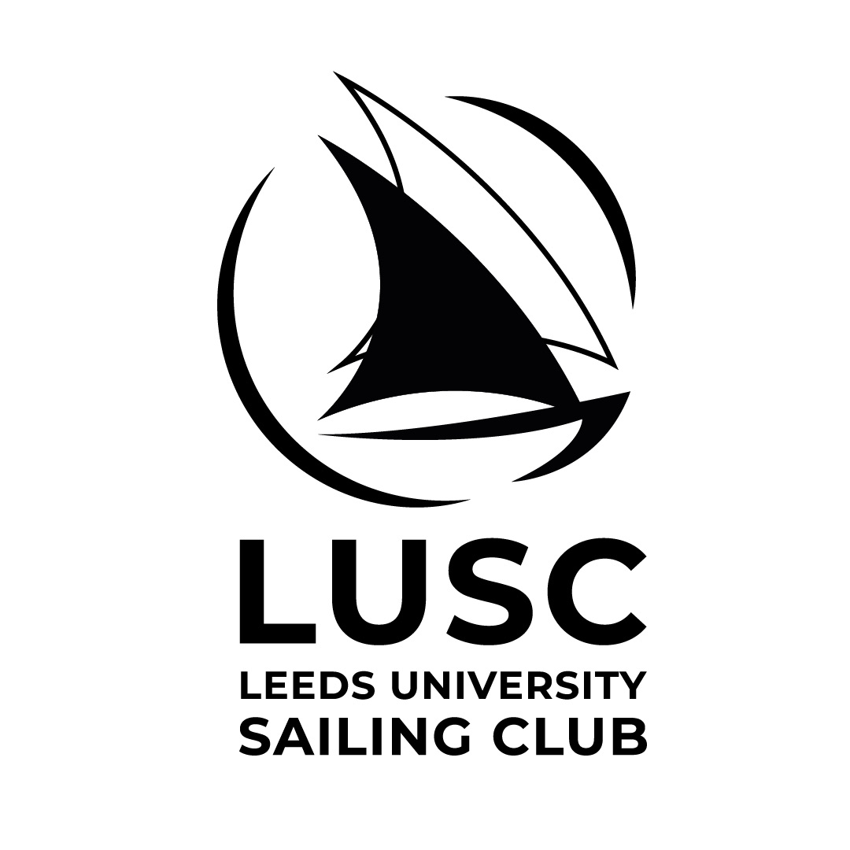

NOTICE OF RACE

Leeds University Sailing Club Halloween Howler 2022

- The Leeds University Sailing Club Halloween Howler 2022, will take place on the 12th and 13thth of November. The event is open to any team meeting the conditions below.
- The organising authority is Leeds University Sailing Club.
- The championship will be sailed at West Riding Sailing Club, near Wakefield in Yorkshire, in two-person dinghies (Fireflies) provided by the organising authority.

Event Format
        - Registration will take place from 08:00 on the Saturday 6th November at West Riding Sailing Club
        - The format and race schedule will be available at registration
        - Unless otherwise notified by email 7 days before the start of registration, there will be a briefing for all competitors at 08.30, at the sailing club, on the first morning and the first warning signal will be at 08.57.

5 Entry and Eligibility
- Entry is invited from University teams, both past and present and sailing clubs from around the UK. However, if fewer than 12 teams have entered by the start of 16th October 2022, the organising authority may accept other entries. Please contact the Organising authority if unsure as to your eligibility on leedssailors@gmail.com.
- All three helms must be members of the affiliated club or association they represent.
- No competitor may sail for more than one team.
- Entry is limited to 18 teams.
- If more than 18 teams apply for entry by the start of 16th October 2020, teams will be accepted in the following order:
  - Winners of the 2021 Halloween Howler,
  - A team representing the host club for this Championship.
  - Two teams, each willing to lend a full fleet of 6 firefly boats to the organising authority.
  - One team willing to lend 2 fireflies as spares to the organising authority.
  - In order of receipt of entry complete with entry fee.
If any team fails to take up their place the next placed team will qualify. If there is doubt about the acceptance of any entry, the race committee shall decide. Entries received after 16th October 2021 will be accepted solely in order of receipt.
- Decisions of the race committee about entry or eligibility shall not be cause for redress. This amends rules 62.1 and 63.1.
- All competitors in all teams shall complete the registration requirements before racing.
- All competitors who will be under 18 years of age on 12th November 2021 shall provide at registration a fully completed and signed RYA parent/guardian declaration form. These competitors must bring a guardian with them for the weekend and will not be permitted to join in with the socials.

Entry Fees and Damage Deposits
The entry deposit is £100 per team and payable with the entry form. If the event is cancelled or postponed by the organising authority due to Covid-19 related causes, a full refund will be given. If the event is cancelled due to weather conditions no refund will be awarded.
Each team will be liable for the cost of damage to boats, equipment and property up to a maximum of £300 per incident. Cover for this amount is required before the team may sail, whether it be by cheque or acceptance of the terms on the entry form. When a team is assessed as liable for damage, it shall restore the deposit to the original value in order to continue sailing. Damage attributed to competitors generally or to an unidentified team will be attributed equally between all teams. A team may apply to the organising authority to determine its responsibility for any damage. The deposit, or any remaining balance of the deposit, will be returned within 28 days after the championship.

Rules
        - Racing will be governed by the rules as defined in the Racing Rules of Sailing (RRS) including appendix D, Team Racing Rules. http://www.sailing.org/racingrules.php/
        - The UK Team Racing Association Team Racing Sailing Instructions will apply. These change some rules in the RRS; they are available on the UKTRA website (www.teamracing.org) and at registration.
        - All races will be umpired. The ISAF Call Book for Team Racing will apply. The organising authority will appoint umpires.
        - In accordance with rule 70.5(a) the right of appeal will be denied.

Personal Flotation Devices and Clothing
Every competitor shall wear an adequate personal flotation device, and either a drysuit, or a "longjohn" wetsuit (minimum 3mm thickness), at all times when afloat.

Acknowledgement of Risk
- A boat is entirely responsible for her own safety, whether afloat or ashore, and nothing, whether in the Notice of Race or Sailing Instructions or anywhere else, reduces this responsibility.
- It is for the boat to decide whether she is fit to sail in the conditions in which she will find herself. By launching or going afloat, the boat confirms that she is fit for those conditions and that her crew is competent to sail and compete in them. All boats submitted on the application must have sailed together before the event.
Nothing done by the organisers can reduce the responsibility of the boat nor will it make the organisers responsible for any loss, damage, death or personal injury, however it may have occurred, as a result of the boat taking part in the racing. The organisers encompass everyone helping to run the race and the event, and include the organising authority, the race committee, the race officer, umpires, patrol boats and beachmasters.
- The provision of patrol boats does not relieve the boat of her responsibilities.
- No alcoholic beverages are to be consumed at the sailing club
- Transport to and from West Riding Sailing Club is the responsibility of the team applying.

Prizes
Prizes will be awarded at the discretion of the organising authority.

By registering for the event and paying an entry fee teams agree with these conditions.

Online Entry Forms are available on the BUSA website (www.busa.co.uk) or can be obtained by emailing leedssailors@gmail.com

