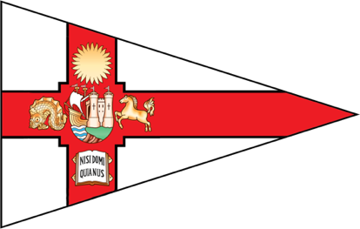**Bristol Brew 2023 - Entry Form**

**University of Bristol Sailing Club**

Saturday 2nd - Sunday 3rd December 2023

Please complete by **Friday 10th November 2023**.

|  |  |
| --- | --- |
| **Team Name** |  |
| **Captain** |  |

|  |  |  |  |
| --- | --- | --- | --- |
| Helm 1 |  | Crew 1 |  |
| Helm 2 |  | Crew 2 |  |
| Helm 3 |  | Crew 3 |  |

***Please provide the telephone numbers and email addresses of the Captain and one other member of the team below. These should be telephone numbers that we can reach you on before and during the event.***

|  |  |
| --- | --- |
| Name of Captain |  |
| Telephone number |  |
| Email address |  |

|  |  |
| --- | --- |
| Name of Team Member |  |
| Telephone number |  |
| Email address |  |

Please email with sailing CV(s) to Ciara at [uob.sailing.eventssec@gmail.com](mailto:uob.sailing.eventssec@gmail.com) by **Friday 10th November 2023.** You will receive confirmation of your team’s place by **Monday 13th November 2023**. The deadline for payment of entry fees is **Friday 17th November 2023**, please include proof of payment.

Please make entry fees payable to:

University if Bristol Students’ Union

Account number: 00424269

Sort code: 60-17-12

Reference: SAI_Brew (team name/uni)