# Event: Bath Robe DATE: 24th-25th February 2024

**SAILING INSTRUCTIONS**

# Addendum A: Event Specific Rules

## A1: Additional Rules

|  |  |
| --- | --- |
| A1.1 RRS D2 applies. Races will be umpired. | **Yes** |
| A1.2 RRS 20 is changed. The Arm Signals in RRS D1.1(e) are required. | **No** |
| A1.3 A boat capsized after her starting signal, with her masthead in the water,  shall retire promptly. | **Yes** |
| A1.4 Providing the flag remains on the mark, a boat may touch any part of the flag of a mark that does not surround the staff of the mark. This changes RRS 31. | **Yes** |
| A1.5 RRS 40 (Personal Flotation Device) applies at all times while afloat. | **Yes** |
| A1.6 Competitors shall wear a wet or dry suit at all times while afloat. | **Yes** |

***A2: Course and Marks, Starting Signals, Prohibited Areas, Other Local Rules***

A2.1 The course will be **S course**, each as defined in Addendum C.

A2.2 The visual starting signals will be **battens**.

The times of starting signals will be: **3,2,1**.

A2.3 The course marks will be described at the briefing.

A2.4 The following are prohibited areas that a boat shall not enter or cross. They rank as obstructions:

1. a) The fishing hatches to the North of the club area and an area 25 metres away from them.

b) A boat shall not sail within 50 metres of a fisherman on the shore, nor within 25 metres of a fishing boat whether drifting or anchored.

***A3: Communication with Competitors***

A3.1 The location of the Official Noticeboard is on the window of the downstairs race office.

A3.2 Signals ashore will be flown on the signal halyard adjacent to the race hut, or announced over a tannoy.

***A4: Intended Format***

Format codes, and the format and scoring rules that apply for each, are stated in Addendum B.

|  |  |  |
| --- | --- | --- |
| **Stage** | **Format Code** | **Additional Information** |
| 1 | HLS | The exact format to be decided and will be announced at the briefing |
| 2 |  |  |
| 3 |  |  |
| 4 |  |  |
| 5 |  |  |

***A5: Other Addenda that Apply***

| K: Supplied Boats | X | ~~L: Keelboat Rules~~ |  | M: Breakdown Delays | X | ~~N: Other Rules~~ |  |
| --- | --- | --- | --- | --- | --- | --- | --- |

**UKTRA EVENT SAILING INSTRUCTIONS**

## Rules

* 1. Racing will be governed by the *rules* as defined in the Racing Rules of Sailing (RRS) including Appendix D, Team Racing Rules.
  2. Add to RRS D2.3 “(h) breaks SI 6.1, A2.4 or a rule in SI Addendum L (if applicable)”. Breaches of these rules may therefore be penalised by the umpires without a protest.
  3. Addenda A, B and C to these Sailing Instructions (SIs) always apply. Other addenda apply only when stated in SI A4 (Format Code) or A5. Green text is for guidance only.
  4. The right of appeal is denied in accordance with RRS 70.5(a).

## Eligibility and Registration

* 1. To become eligible a team shall register as required by the Notice of Race or, if not specified, on arrival at the event.
  2. After registration, a team member may only be changed with the prior consent of the race committee, which will only be given when the team member is unexpectedly unable to sail.

## Communication with Competitors

* 1. Notices to competitors will be posted on the Official Noticeboard (ONB). SI A3.2 specifies whether signals made ashore will be announced or displayed on the Club flagpole.
  2. Changes to these SIs will be posted on the ONB not less than 10 minutes before the warning signal of the first race affected.

## Event Format and Schedule of Races

* 1. The intended format of the event is described in SI A4.
  2. The schedule of races will be displayed on the ONB. Any changes, and schedules for subsequent races, will be displayed not less than 10 minutes before the start of those races.
  3. Every race will be assigned a race number in the race schedule.
  4. The number of the next race to start will be displayed on the starting vessel from before, or promptly after, the warning signal until the starting signal. The race committee may at any time postpone a race and reschedule it at a later time.
  5. When a race has been abandoned and the result would not affect which teams qualify for a further stage, the race committee may choose not to re-sail the race.

## Starting Signals, Starting Marks and Finishing Marks, Starting Procedure

* 1. The visual starting signals and times are specified in SI A2.2. The signal sequence will be:

|  |  |  |  |  |
| --- | --- | --- | --- | --- |
| *Signal meaning* | *Minutes before starting signal* | *Sound Signal* | *Visual signal* | |
| *Flags* | *Battens or Shapes* |
| Warning | 3 or 5 | One | Class flag up | 3 displayed |
| Preparatory | 2 or 4 | One | Flag P up | 2 displayed |
| One-minute | 1 | One | Flag P down | 1 displayed |
| Starting | 0 | One | Class flag down | None |

* 1. Attention may be drawn to an imminent warning signal by a series of short sound signals.
  2. Starting signal times shall be taken from the start of each sound signal. The failure of a visual signal shall be disregarded. This changes RRS 26.
  3. When the starting signal is also the warning signal for the next race, the class flag will remain displayed, or 3 battens or shapes will be displayed.
  4. The starting line will be from the mast of a committee vessel and the nearby starting mark. The finishing line will be from the mast of a committee vessel and the nearby finishing mark.
  5. When a boat is subject to RRS 29.1, flag X need not be displayed for longer than 1 minute after the starting signal; this changes RRS 29.1. The race committee may hail the sail numbers or the total number of premature starters.
  6. A boat shall not start more than 2 minutes after her starting signal.
  7. After a general recall, succeeding races may be delayed for the recalled race. Attention is drawn to SI 4.4.

## Event Continuity

* 1. A boat shall not be sailed in a manner that is likely to cause damage.
  2. Before starting and after finishing or retiring, boats shall sail to minimise any delay to the race schedule and without interfering with any race in progress.
  3. The race committee may move a mark at any time. RRS 27.2 and RRS 33 are deleted.
  4. The time limit for a race will be 30 minutes.

## Protests, Requests for Redress, Scoring and Penalties

* 1. Protests and requests for redress that have not been decided afloat shall be notified to the race office within 10 minutes after the relevant incident or, if the incident is afloat, within 10 minutes after coming ashore.
  2. When the outcome of a protest or request for redress would not affect which teams qualify to a later stage, the protest committee may refuse to hear it. This changes RRS 63.1.
  3. When the race umpires decide that a boat has broken RRS 14 and there is damage or injury, they may penalise her team by half a race win without a hearing. The boat will be informed as soon as practical and may request a hearing. Any penalty after a hearing will be in accordance with RRS D3.1(e). This changes RRS 63.1.
  4. When a boat is scored NSC (did not sail the course) or breaks SI 5.7, 6 points shall be added to her score without a hearing. This changes RRS 64.1 and A5.2.
  5. When a competitor breaks RRS 40 or SI A1.6 (wet or dry suits), the race committee may penalise the competitor's team half a race win without a hearing. This changes RRS 63.1.
  6. After a hearing, the penalty for a breach of a rule, other than a rule of RRS Part 2, RRS 31 or RRS 42, that has had no effect on the outcome of a race, shall be at the discretion of the protest committee, and may be no penalty. This changes RRS D3.1(e).

## Risk Statement

* 1. Rule 3 of the Racing Rules of Sailing states: "The responsibility for a boat’s decision to participate in a race or to continue racing is hers alone."

Sailing is by its nature an unpredictable sport and therefore inherently involves an element of risk. By taking part in the event, each competitor agrees and acknowledges the risk statement included in the Notice of Race. If the Notice of Race does not include a risk statement, the RYA Risk Statement in Addendum A to Appendix J of the RYA publication of the RRS shall apply.



**Index to SI Addenda**

**Addenda That Always Apply**

A Event Specific Rules

B Event Format

C Courses

**Other Addenda**

K When Boats are Supplied by the OA

L Keelboat Rules

M Change of Format due to Breakdown

N Additional Rules, including local rules

**Race Formats, Schedules & Tie-breaks**

E Round-Robins in Groups

F Random Pairs

H HLS League

G Swiss League

J Special Event Format (provided by RC)

**Addendum B: Event Format**

The intended format for each stage of the event shall be stated in SI A4, selected from the following standard formats, or from an Addendum J provided by the race committee and included with these Sailing Instructions. The race committee may change the format as provided in RRS D4.2(b).

|  |  |  |
| --- | --- | --- |
| **Code** | **Description** | **Format & Scoring Rules** |
| Groups | Round-robin(s) in group(s) | RRS D4.3, D4.4, and Addendum E |
| Random | Random pairs (2-boat teams only) | Addendum F |
| HLS | HLS league | Addendum H |
| Swiss | Swiss league | Addendum G |
| RC | Other format provided by race committee | Addendum J |
| KO | Knock-out | RRS D4.5 |

The specified addendum for each format contains the necessary race schedules, or procedures to create the schedules, together with rules which shall apply for scoring and breaking ties.

For each stage, any assignment of teams to groups or matches, and the method of qualification for the next stage, shall be stated as ‘Additional Information’ in SI A4.

**For a Round-Robin stage,** the intended number of round-robins in the stage shall be stated. Any carry-forward of wins from a previous stage, weighting applied to scores from an earlier stage, or change to the percentage in RRS D4.3(b) shall also be specified.

**For a Knock-Out stage,** RRS D4.5 requires the number of race wins required to win a match to be stated. If not stated the winner shall be the first team to score two race wins. A knock-out stage may be preceded by a one-race repechage between two teams to decide the last qualifier.

# An example of the information that should be entered in SI A4:

|  |  |  |
| --- | --- | --- |
| **Stage** | **Format Code** | **Additional Information** |
| 1 | HLS | Top third (rounded up) to Gold group in Stage 2, next third to Silver, remainder to Bronze |
| 2 | Groups | Gold, Silver, Bronze round-robins (one round each).  Top 3 in Gold to Stage 4. 4th in Gold and 1st in Silver to Stage 3. |
| 3 | KO | Repechage (1 race) between 4th in Gold and 1st in Silver.  Winner (or if stage 3 not sailed, 4th in Gold) to Stage 4. |
| 4 | KO | Semi-finals: Gold 1st v repechage winner & Gold 2nd v Gold 3rd.  First to score 2 race wins. |
| 5 | KO | Final, first to score 3 race wins  Petit-final, first to score 2 race wins |

# Addendum C: Courses

***C1 'S' Course***

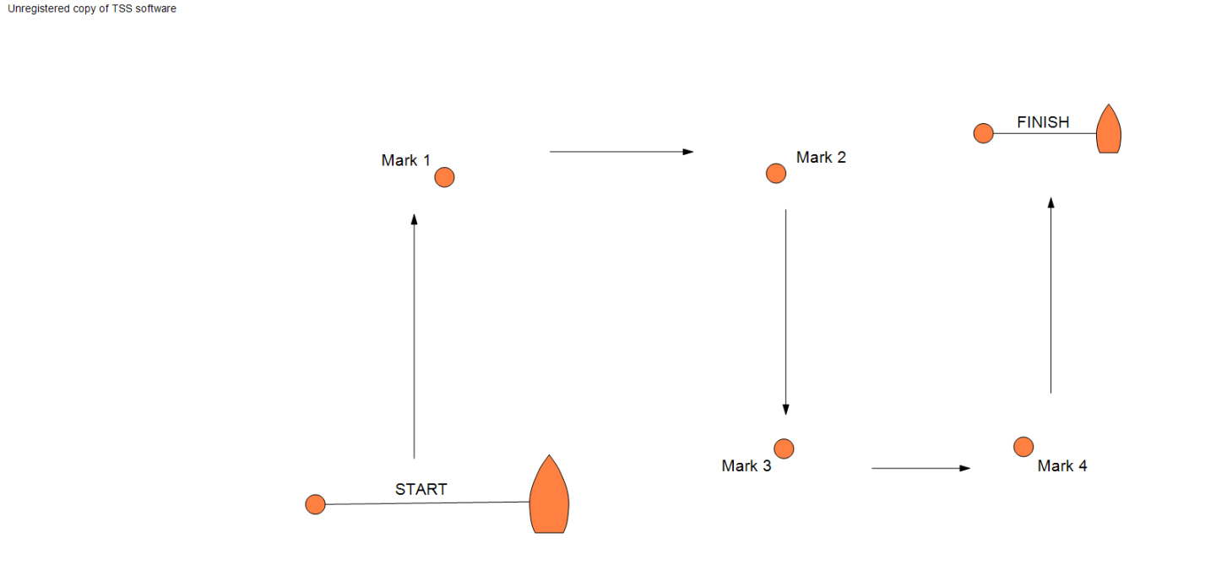

**Addendum H: HLS League**

H1 Teams for each race will be selected randomly. A team will not sail any other team more than once in a stage.

H2 If the full round robin has been completed, teams shall be ranked on the basis of RRS D4.3(a) and ties broken using RRS D4.4.

H3 If the full round robin has not been completed, teams shall be ranked in order of their percentages of races won. RRS D4.3(b) is deleted, and RRS D4.4 is changed to:

(a) Ties shall be broken in the following order in favour of:

* + 1. if all tied teams have met, the number of races won when they met, highest first;
    2. if all tied teams have met, the total points scored when they met, lowest first;
    3. the average points per race scored by each tied team in all its races, lowest first;
    4. the average of the percentage wins of teams that each tied team beat, highest first;
    5. the average of the average points scored in all races by teams that each tied team beat, lowest first;
    6. a sail-off if possible, otherwise a game of chance.

(b) If a tie is partially resolved by one of the above, then the remaining ties shall be broken by starting again at D4.4(a)(1).

H4 For the purposes of breaking ties using H3, if a team is penalised a race win, or part thereof, for an incident when not racing, the penalty is changed to include 6 points, or 3 points respectively, added to the team's overall score. This changes RRS 63.1.

# Addendum K: When Boats are Supplied by the Organising Authority

K1 EQUALISATION AND ALLOCATION

1. The organising authority and race committee will take reasonable steps to equalise the boats.
2. The race committee will allocate the boats to be used in each race.
3. Neither the allocation of boats, nor any variation between the boats and their equipment, shall be grounds for redress. This changes RRS 62.1.

K2 (a) Supplied boats shall be deemed to conform to their class rules.

(b) When class rules change RRS 42, such changes shall not apply.

K3 RESPONSIBILITY FOR A BOAT

1. A boat shall remain the responsibility of the team until handed over to the race committee or the next team to use that boat. Boats shall be handed over as empty of water as practical and in racing trim.
2. Competitors are responsible for inspecting their boats before racing.
3. Competitors shall report any defects, damage or breakdown to the race committee at the first reasonable opportunity.
4. When to continue racing after damage or a breakdown risks further damage to the boat, she shall retire immediately.

K4 PROHIBITED ACTIONS

(a) Adjusting or altering the tension of standing rigging, excluding the backstay when fitted, except with the authorisation of the race committee;

(b) Adding to, omitting or altering the equipment supplied, including cutting or shortening any sheets, control lines or other running rigging;

(c) Removing or replacing any equipment without the consent of the race committee;

(d) Marking directly on the hull or deck with permanent ink;

(e) Perforating sails, even to attach tell tales;

(f) Boarding or using a boat without the consent of the race committee.

K5 REQUIRED ACTIONS AT END OF EACH DAY

At the end of each sailing day, the crew shall complete the following tasks:

* + 1. Sails shall be rolled, bagged and placed as directed.
    2. The boat shall be left in the same state of cleanliness as when first boarded that day.
    3. The crew shall comply with any directions posted on the boats or otherwise given to the crew by the race committee.
    4. The boat shall be returned to the dock or other notified location and secure it safely in accordance with any local instructions.

At the end of the final day for a particular boat, the boat shall be cleaned, and all rubbish, tape and marks removed.

**Addendum M: Change of Format due to Breakdown**

# M1 If races in a 3v3 event are likely to be unduly delayed by a boat being repaired or replaced, the race committee may act under D4.2(b) and designate some races to be raced by teams of 2 (i.e. 2v2) until there are sufficient boats to resume 3v3.

# M2 Teams will be notified of this change orally, either ashore, or by the start boat or umpires on the water. The teams may choose which of their three helm-crew pairings does nor race.

# M3 For the purposes of scoring, the team winning the race shall have 5 points (equivalent to its third boat finishing in 5th place) added to its score, and the team losing the race shall have 6 points added to its score.

# 