# LONDON SIX PACK

# 16th - 17th March 2024 SAILING INSTRUCTIONS

## Rules

* 1. Racing will be governed by the *rules* as defined in the Racing Rules of Sailing (RRS) including Appendix D, Team Racing Rules.
  2. When required by RRS 40 and the RYA Prescription thereto, each competitor shall wear a personal flotation device (PFD) that complies with ISO 12402-5 -Level 50 or equivalent, unless a higher specification is specified in the notice of race.
  3. Addenda A, B and C to these sailing instructions (SIs) always apply. Other addenda apply only when so stated. The letters D and I are not used to identify addenda.
  4. The right of appeal is denied in accordance with RRS 70.5(a).

## Eligibility and Registration

* 1. To become eligible a team shall register as required by the notice of race or, if not specified, on arrival at the event.
  2. After registration, no team member may be changed without the prior consent of the race committee which will be given only in exceptional circumstances.

## Event Format and Schedule of Races

* 1. The intended format of the event is described in SI Addendum B.
  2. The initial schedule of races will be displayed on the official online notice board. Any changes thereto and schedules for subsequent races will be displayed not less than 10 minutes before the start of those races.
  3. Every race will be assigned a race number in the race schedule.
  4. The number of the next race to start will be displayed on the committee vessel no later than the warning signal (or promptly thereafter if co-incident with the previous start) until the starting signal. The race committee may at any time postpone a race and reschedule it at a later time.
  5. When a completed race has been abandoned and the result would not affect which teams qualify for a further stage, the race committee may cancel the race.

## Protests, Requests for Redress and Penalties

* 1. Protests and requests for redress that have not been decided afloat shall be notified to the race office within 10 minutes after the relevant incident or, if the incident is afloat, within 10 minutes after coming ashore.
  2. When the outcome of a protest or request for redress would not affect which teams qualify to a later stage, the protest committee may refuse to hear it. This amends RRS 63.1.
  3. When RRS D2 applies and the race umpires together with one other umpire (when available) decide that a boat has broken RRS 14 and there is damage or injury, they may penalize her team by half a race win without a hearing. The boat will be informed as soon as practical and may request a hearing. Any penalty after a hearing will be in accordance with RRS D3.1(e). This amends RRS 63.1.
  4. When a boat is scored NSC (did not sail the course), 6 points shall be added to her score. This amends RRS A5.2.
  5. When the race committee decides that a competitor has broken SI A1.5, personal flotation device, or SI A1.6, wet or dry suits, it shall penalize the competitor's team one race win without a hearing. This amends RRS A5.2.
  6. When the protest committee decides that a breach of a rule, other than a rule of RRS Part 2, has had no effect on the outcome of a race, it may make any arrangement it decides is equitable, which may be to impose no penalty. This amends RRS 64.2 and D3.1.
  7. When a boat takes a penalty turn that includes a tack, the head of any spinnaker shall be below the main-boom gooseneck from the time the boat passes head to wind until she is on a close-hauled course. This amends RRS 44.2.
  8. A boat may not protest another boat under SI Addendum L. This amends RRS D1.2(a).
  9. Add sub-paragraph (h) to RRS D2.3 as follows

(h) breaks a rule in SI Addendum L.

## Risk Statement

* 1. Rule 3 of the Racing Rules of Sailing states: "The responsibility for a boat’s decision to participate in a race or to continue racing is hers alone."

Sailing is by its nature an unpredictable sport and therefore inherently involves an element of risk. By taking part in the event, each competitor agrees and acknowledges the risk statement as included in the Notice of Race. If the Notice of Race does not include a risk statement, the RYA Risk Statement will apply as included in Addendum A to Appendix J of the RYA publication of the RRS.



***Index to SI Addenda***

*Not all addenda will apply to every event; see SIs 1.4 and A5.1.*

Addenda That Always Apply

A Event Related Rules

B Event Format

C Courses

Race Formats and Schedules

E Round-Robins in Groups, Schedules and Tie Breaks

F Random Pairs, Schedules and Tie Breaks

G Swiss League, Schedules and Tie Breaks

H HLS League, Schedules and Tie Breaks

J Special Event Format (provided by race committee)

Other Addenda

K When Boats are Supplied by the Organizing Authority

L Boat Handling Rules

# Addendum A

Event Related Rules

# Event:

## Section 1: Additional Rules Delete as required

|  |  |
| --- | --- |
| A1.1 RRS D2 applies. Races will be umpired. | Yes |
| A1.2 RRS D1.1(d) applies. Arm Signals are required. | No |
| A1.3 (1) A boat capsized after her starting signal, so that her masthead is in the water, shall retire promptly.  OR  (2) A boat capsized after her starting signal, so that both her gunwales are touching the water or her mast is stuck in the bottom, shall retire promptly. | (1) |
| A1.4 (1) Provided the flag remains on the buoy there shall be no penalty when a boat touches any part of a flag which does not surround the staff of a mark. This amends RRS 44.1.  OR  (2) Rule 31 is changed to:  While racing, neither the crew nor any part of a boat’s hull shall touch a starting mark before starting, a mark that begins, bounds or ends the leg of the course on which she is sailing, or a finishing mark after finishing. In addition, while racing, a boat shall not touch a race committee vessel that is also a mark. | (2) |
| A1.5 A personal flotation device that complies with SI 1.2 shall be worn at all times whilst afloat. | Yes |
| A1.6 Wet or dry suits shall be worn at all times when afloat. | Yes |
| A1.7 Spinnakers, trapezes and the gear specifically provided for the utilisation of these shall not be used. | Yes |
| A1.8 RRS D4.2(b) is changed to:  When a round-robin is terminated, any round-robin in the stage in which 60% or more of the full schedule of races has been completed shall be scored as complete. If fewer races have been completed, it is at the discretion of the Organising Authority whether the round-robin shall be scored. | Yes |

***Section 2: Other Rules for Boats***

A2.1 Continuity

Before starting and after finishing or retiring, boats shall sail to minimise any delay to the race schedule and without interfering with any race in progress.

A2.2 Electronic Devices and Communications

While racing,

* + - * 1. the use of electronic instruments is prohibited other than compass, watches and small video devices such as Go-Pros;
        2. boats shall not transmit on any electronic communication device (including mobile phones) except in an emergency, or in response to a request from the race committee. See also RRS D1.1(g).

A2.3 When Leaving or Returning to the Berth or Mooring

Boats shall comply with local regulations, including speed restrictions and navigation marks, while leaving or returning to the berth or mooring.

A2.4 Required Actions at End of each Day

At the end of each sailing day, the crew shall complete the following tasks:

* + 1. Sails shall be rolled, bagged and placed within the boats, as directed.
    2. The boat shall be left in the same state of cleanliness as when first boarded that day.
    3. The crew shall comply with any directions posted on the boats or otherwise given to the crew by the race committee.
    4. The boat shall be taken off the water and returned to its position in the dinghy park, with covers on and booms up.

A2.5 At the end of the final day for a particular boat, the boat shall be cleaned (cabin and decks) all trash & recycling removed.

## Section 3: Communications with Competitors

A3.1 Notices to Competitors

Notices to competitors will be posted on the official notice board located in the clubhouse used for the event.

A3.2 Changes to Sailing Instructions

Changes to these SIs will be signalled by flying flag L from Club flagpole. Such changes will be posted on the official notice board not less than 10 minutes before the warning signal of the first affected race.

A3.3 Signals Made Ashore

Signals made ashore will be displayed on the Club flagpole. If different, they will be displayed from the Committee Boat.

## Section 4: Courses, Marks, Starting & Finishing Lines, Obstructions and Time Limits

A4.1 Racing Area

The racing area will be King George V Sailing Club Reservoir. Competitors will be informed of the sailing area at the briefing on Saturday at 9am.

A4.2 Course

The course will be course C1 as described in SI Addendum C.

A4.3 Marks

All course marks will be round white buoys with coloured numbered flags, excluding start and finish pins. Competitors will be informed of any changes to the marks being used at the briefing on the Saturday morning.

A4.4 Moving Marks

The race committee may move marks of the course at any time. RRS 27.2 and RRS 33 will not apply.

A4.5 Obstructions

Competitors will be informed of any obstructions to be aware of at the competitors briefing on the Saturday morning.

A4.6 Starting Line

The starting line will be between the mast of a committee vessel and a starting mark.

A4.7 Finishing Line

The finishing line will be between the bow of a committee vessel and a finishing mark.

A4.8 Time Limits

The time limit for each race shall be 30 minutes.

## Section 5: Starting Procedure

A5.1 Starting Signals

Races will be started by using the signals and timing selected in the following table.  Times shall be taken from the start of each sound signal; the failure of a visual signal shall be disregarded. This amends RRS 26.

***Mark '✔ ' in the top row, one column for timing and one column for visual signals***

|  |  |  |  |  |  |
| --- | --- | --- | --- | --- | --- |
| Event System | ***✔*** |  |  |  | ***✔*** *(triple battens)* |
| *Signal* | *Timing options* | | Sound | *Visual signal options* | |
|  | *Minutes before starting signal* | |  | *Flags* | *Battens or orange cylinders* |
| Warning | 3 | 5 | One | Class flag up | 3 displayed |
| Preparatory | 2 | 4 | One | Flag P up | 2 displayed |
| One-minute | 1 | 1 | One | Flag P down | 1 displayed |
| Starting | 0 | 0 | One | Class flag down | None |

However, when the starting signal is also the warning signal for the next race, the class flag will remain displayed, or 3 battens or cylinders will be displayed.

Attention may be drawn to an imminent warning signal by a series of short sound signals.

A5.2 Recall Signals

When a boat is subject to RRS 29.1, flag X need not be displayed for more than 1 minute after the starting signal; this amends RRS 29.1. The race committee may hail the sail numbers or the total number of premature starters.

A5.3 Time Limit for Starting

A boat that fails to start within 2 minutes of her starting signal shall be scored RET (retired) without a hearing. This amends RRS 63.1 and D3.1(a).

A5.4 General Recall

After a general recall, succeeding races may be delayed for the recalled race. Attention is drawn to SI 3.4.

## Section 6: Addenda and Local Rules

A6.1 Rules in SI Addenda

The rules in the following SI addenda apply throughout the event:

|  |  |  |
| --- | --- | --- |
| Addendum K | When Boats are Supplied by the Organizing Authority | Yes |
| Addendum L | Boat Handling Rules | Yes |
|  |  |  |
|  |  |  |

A6.2 local rules

The following local rules also apply:

Buoyancy Aids must be worn at all times when on the water or on the pontoon.

# Addendum B

Event Format

The format for each stage of the event shall be selected from the following standard formats, or from an Addendum J provided by the race committee and included with these sailing instructions. The specified addendum for each format contains the necessary race schedules, or procedures to create the schedules, together with rules which shall apply for scoring and breaking ties.

Each stage of an event may use a different format. The race committee may change the format as provided in RRS D4.2(b).

|  |  |  |
| --- | --- | --- |
| **Code** | **Description** | **Format Rules** |
| Groups | Round-robin(s) in group(s) | RRS D4.3, D4.4, and Addendum E |
| Random | Random pairs (2-boat teams only) | Addendum F |
| Swiss | Swiss league | Addendum G |
| HLS | HLS league | Addendum H |
| RC | Other format provided by race committee | Addendum J |
| KO | Knock-out | RRS D4.5 |

For each stage, any assignment of teams to groups or matches and the method of qualification for the next stage shall be stated.

For a round-robin stage, the number of round-robins in the stage, any carry-forward and weighting applied of scores from an earlier stage and any change to the percentage in RRS D4.3(b) shall be stated.

For a Knock-Out stage, the number of race wins required to win a match shall be stated, as RRS D4.5. However, if not stated the winner shall be the first team to score two race wins.

The intended format is

|  |  |  |
| --- | --- | --- |
| **Stage** | **Format Code** | **Additional Information** |
| 1 | HLS | Top half to Gold, bottom half to Silver in stage 2 |
| 2 | Groups | Gold & Silver |
| 3 | KO | Silver Surfer: 4th Gold vs 1st Silver |
| 4 | KO | Semi-Finals: 1st Gold vs Stage 3 1st & 2nd Gold vs 3rd Gold. First to 2 Race Wins. |
| 5 | KO | Final: First to 2 Race Wins, Winner is 1st Petit-final: First to 2 Race Wins, Winner is 3rd |

# Addendum C

Courses

C1 'S' Course

*This is the standard team racing course for multi-team dinghy events. In most conditions it enables rolling starts at 3 minute intervals.*

Start, round marks 1 then 2 to starboard, round marks 3 then 4 to port, Finish

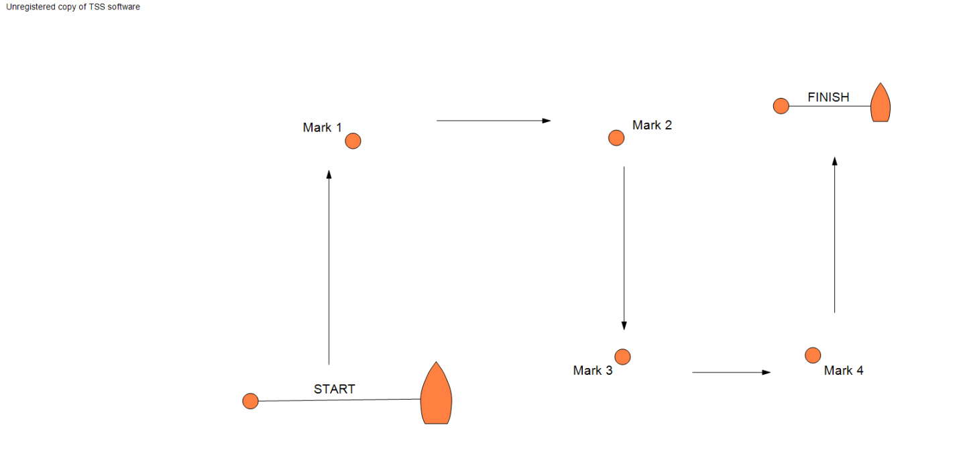

C2 Rectangular Course

*If rolling starts are required, separate start and finishing lines should be laid.*

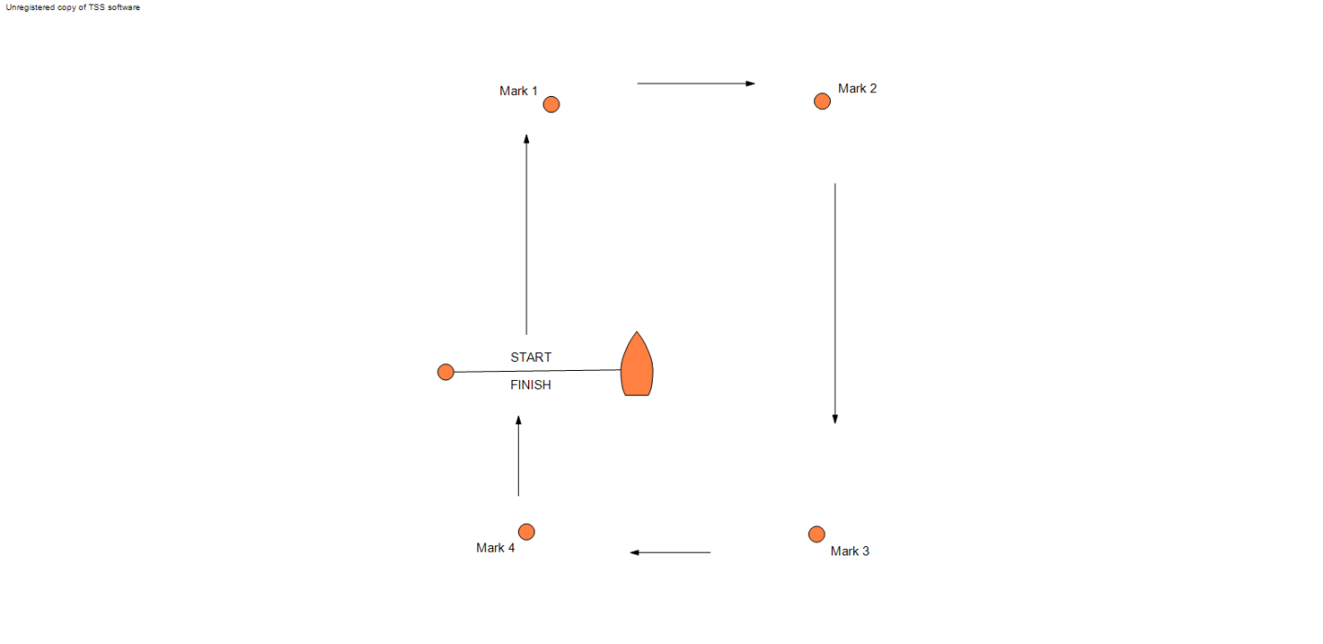

Start, round marks 1, 2, 3 and 4 in order, then cross the start/finish line.

The marks shall be rounded to port or starboard and the number of laps to be sailed shall be as displayed on the official notice board or on the committee vessel.

C3 Other Course

As displayed on the official notice board.

# Addendum E

Round Robins in Groups

E1 In the first stage of an event, the teams may be assigned to a single group, seeded to groups based on past performance or assigned randomly. In subsequent round-robin stages the highest placed teams will be assigned to one group, the next highest placed teams to another group, and so on.

E2 The stage shall be scored in accordance with RRS D4.3 and D4.4.

# Addendum F

Random Pairs

F1 In this stage boats are scored individually while competing as part of a team.

F2 In each race of this stage boats will be randomly assigned to race in a team with another boat against another team of randomly allocated boats.

F3 During this stage, the following rules will apply:

F3.1 Each boat in the winning team of each race shall be scored one race win. Each boat in the losing team shall be scored zero race wins.

F3.2 Boats shall be ranked in order of number of race wins, highest number first. If the boats have not completed an equal number of races, they shall be ranked in order of the percentage of races won

F3.3 Ties will be broken using RRS D4.4 with D4.4(a) amended as follows (changes in **bold**)

(a) If the tied boats have all sailed each other at least once in the stage, the tie shall be broken in the order below.

(1) Percentage of races won in all races between the tied **boats**, highest first;

(2) Average **team** points per race in all races between the tied **boats**, lowest first;

(3) If two **boats** remain tied, the winner of the last race between them;

(4) Average points per race in all races against common **teams of** opponents, lowest first;

(5) A sail-off if possible, otherwise a game of chance.

# Addendum H

HLS League

H1 Teams for each race will be selected randomly.

### Rules for this stage

H2 If the full round robin has been completed, teams will be ranked on the basis of RRS D4.3(a) and ties broken using RRS D4.4. RRS D4.3(b) does not apply.

H3 If the full round robin has not been completed, teams will be ranked in order of their percentages of races won. Any ties shall be broken in accordance with the following rules and RRS D4.4 is changed accordingly. Ties shall be broken in the following order in favour of:

* + 1. If all tied teams have met, the number of races won when the tied teams met.
    2. If all tied teams have met, the points scored when the tied teams met.
    3. The sum of points scored in all races divided by the number of races sailed.
    4. For each tied team, the sum of the percentages of races won by the teams they beat, calculated as H3 above, divided by the number of races they won.
    5. For each tied team, the sum of the average points per race for the teams they beat, divided by the number of races they won.
    6. A sail-off if possible, otherwise a game of chance.

H4 In H3(b), H3(c) and H3(e) the team with the lowest number shall be ranked first; in all other cases the team with the highest number shall be ranked first.

H5 If a tie is partially resolved by one of the above, then the remaining ties shall be broken by starting again at H3(a).

H6 For the purposes of H3(c), if a team is penalized a race win, or part thereof, the penalty is changed to include 6 points added to the team's overall score (or 6 points pro-rated e.g. half a race win is 3 points).

# Addendum J

Special Event Format

*If required, this addendum is to be provided by the race committee. See also SI Addendum B.*

# Addendum K

When Boats are supplied by the Organizing Authority

K1 Equalisation and Allocation

1. The organizing authority and race committee will take all reasonable steps to equalise the boats.
2. The race committee will allocate the boats to be used in each race.
3. Neither the allocation of boats, nor any variation between the boats and their equipment, shall be grounds for redress. This amends RRS 62.1.

K2 Supplied boats shall be deemed to conform to their class rules;

K3 When class rules change RRS 42, such changes shall not apply;

K4 Responsibility for a Boat

1. A boat shall remain the responsibility of the team until handed over to the race committee or the next team to use that boat. Boats shall be handed over as empty of water as practical and in racing trim.
2. Competitors are responsible for inspecting their boats before racing.
3. Competitors shall report any defects, damage or breakdown to the race committee at the first reasonable opportunity.
4. When to continue racing after damage a breakdown risks further damage to the boat, she shall retire immediately.

# Addendum L

Boat Handling Rules

L1 Application

The rules in this Addendum apply only to boats supplied by the Organizing Authority.

L2 Actions Prohibited at All Times

The following actions are prohibited at all times, unless permitted by SI L3:

(a) Adjusting or altering the tension of standing rigging, excluding the backstay when fitted;

(b) Using the shrouds (including any inner shrouds) above the turnbuckle or other device to adjust the stay, to facilitate tacking, gybing or steering;

(c) Using a winch to adjust the mainsheet, backstay or vang;

(d) Using a reef line as an outhaul;

1. Omitting any headsail car or turning block before sheeting onto a winch;
2. Adding to, omitting or altering the equipment supplied. In particular, cutting or shortening of any sheets, control lines or other running rigging;
3. The removal or replacement of any equipment without the consent of the race committee;
4. Sailing the boat in a manner that it is reasonable to predict would cause damage;
5. Moving equipment from its normal stowage position except when being used;
6. Boarding a boat without the consent of the race committee;
7. Taking a boat from its berth or mooring without the consent of the race committee, or while flag AP is displayed ashore;
8. On a keelboat hauling-out or cleaning surfaces below the waterline;
9. Marking directly on the hull or deck with permanent ink;
10. Perforating sails, even to attach tell tales;
11. The use of any equipment for a purpose other than that intended.

L3 Permitted Actions

Notwithstanding SI L2, the tools and equipment in SI L3.1 may be taken on board and the actions in SI L3.2 are permitted.

L3.1 The following tools or equipment may be taken on board:

1. Safety knives, each with retractable blade or sheath
2. Basic hand tools
3. Electrical tape
4. Rope (elastic or otherwise) of 4mm diameter or less
5. Marking pens
6. Tell tale material
7. Watches and timers
8. Shackles and clevis pins
9. Velcro tape

L3.2 The following are permitted tasks:

1. Any action considered necessary for the safety of the crew
2. Changing the number of purchase for the mainsheet
3. Lazy sheets and control lines may be used to aid hiking; this changes RRS 49.1.
4. Prevent fouling of lines, sails and sheets
5. Attach tell tales
6. Prevent sails being damaged or falling overboard
7. Make minor repairs and permitted adjustments.

