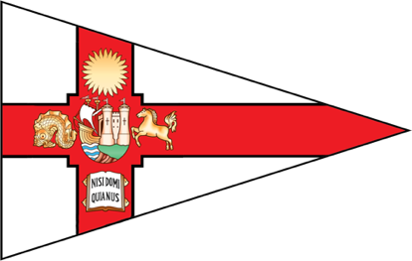**Bristol Brew 2024 - Entry Form**

**University of Bristol Sailing Club**

Saturday 30th November- Sunday 1st December 2024

Please complete by **Friday 15th November 2024**.

|  |  |
| --- | --- |
| **Team Name** |  |
| **Captain** |  |

|  |  |  |  |
| --- | --- | --- | --- |
| Helm 1 |  | Crew 1 |  |
| Helm 2 |  | Crew 2 |  |
| Helm 3 |  | Crew 3 |  |

***Please provide the telephone numbers and email addresses of the Captain and one other member of the team below. These should be telephone numbers that we can reach you on before and during the event.***

|  |  |
| --- | --- |
| Name of Captain |  |
| Telephone number |  |
| Email address |  |

|  |  |
| --- | --- |
| Name of Team Member |  |
| Telephone number |  |
| Email address |  |

Please email with sailing CV(s) to Ciara at [uob.sailing.eventssec@gmail.com](mailto:uob.sailing.eventssec@gmail.com) by **Friday 15th November 2024.** You will receive confirmation of your team’s place by **Monday 18th November 2024**. The deadline for payment of entry fees is **Friday 22nd November 2024**. Late payments will incur a fee as per the Notice of Race.

Please make entry fees payable to:

University of Bristol Students’ Union

Account number: 00424269

Sort code: 60-17-12

Reference: SAI_Brew (team name/uni)