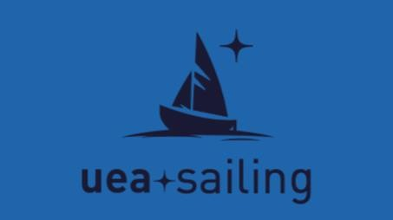 

# UEA Unicorn

**16-17th** **November 2024 Notice of Race**

## Organising Authority

The Organising Authority (OA) will be UEA Sailing Club in cooperation with Norfolk Broads Yacht Club. Contact details: [uea.sailing@uea.ac.uk](mailto:ueasailingclub@gmail.com)

## Venue

The event will be sailed on Wroxham Broad. The Norfolk Broads Yacht Club is the host club and can be found at the following post code: NR12 8TS.

## Entry

* 1. A maximum of 15 teams will be allowed to compete. Teams should complete the entry form no later than the 1st of November 2024. Entries will be awarded on a first-come-first-served basis.
  2. The OA reserves the right to reject any entry based on previous behaviour at any team racing event.
  3. There is an entry fee of £200 for the first team entered from each organisation, and £150 for any subsequent teams from the same organisation. Payment must be made after the entry form is completed and invoices can be generated at request. This must be paid in full before 9:00 18 November 2023.
  4. If a team withdraws before the 1st of November 2024, their entry fee will be refunded. Any team withdrawing after this date must still pay the entry fee.
  5. A damage deposit of £300 shall be made available at registration. This deposit is the maximum amount payable for any one incident.
  6. Any damage caused by a team will result in a deduction from the damage deposit.
  7. Any remaining damage deposit will be returned immediately following the conclusion of the event.
  8. If the damage deposit is used, it must be paid before the team is allowed to race again.

## Event format and schedule

* 1. The event will run in two stages. Stage one is a round robin involving all teams. Stage two is knockout rounds consisting of: semi-finals, petit final and grand final.
  2. The semi-finals and petit final will have a best-of-three format.
  3. The grand final will have a best-of-five format if time permits.
  4. A repercharge round may be run depending on scheduling. This will consist of 1 race per match up, where the lowest scoring team in stage 1 will race against the second lowest and the winner stays on to face progressively more successful teams as ranked in stage 1.
  5. The OA reserves the right to change race schedules providing fair racing for the competitors.
  6. The provisional schedule is as follows:

|  |  |  |
| --- | --- | --- |
| Saturday | 08:00 | Registration opens |
| Saturday | 09:00 | Registration closes; competitor briefing |
| Saturday | 09:30 | First warning signal |
| Saturday | 16:00 | Racing finished for the day |
| Sunday | 09:00 | First warning signal |
| Sunday | 12:00 | Stage two begins |
| Sunday | 15:00 | Prize giving ceremony |

## Boats and crew

* 1. The event will be sailed in Firefly dinghies supplied by the OA.
  2. All necessary equipment, including sails, will be supplied by the OA.
  3. No electronic equipment, excluding watches, shall be carried on the boats during racing.
  4. Each boat shall be sailed by a helm and a crew at all times.
  5. Each team shall have a minimum of two male and two female competitors unless excused by the OA.

## Course

* 1. The event will use a Starboard S course.
  2. The course will be altered during racing as required by changing wind direction.

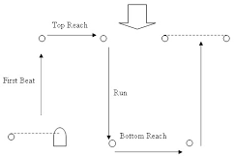

## Rules

* 1. The event will be governed by the Racing Rules of Sailing, including appendix D, as defined by World Sailing.
  2. Umpires will be present to uphold the rules as required.
  3. The OA will notify competitors of any changes to these rules.
  4. Additions to the rules:

* + 1. Any competitor or team that abuses the umpire, race management or event direction teams will be fined one race win immediately. Any further violations will result in the team being disqualified from the event and immediately prevented from continuing to compete.

## Media and images

* 1. By entering the event, all competitors agree to having pictures and films taken of them by the OA. Any exceptions to this shall be declared before the start of the event.
  2. The OA reserve the right to use any images and films recorded at the event freely.
  3. Competitors may be required to use action cameras installed on the boats during racing, as directed by the OA.
  4. All media will be made available to competitors after the event, where possible.
  5. Competitors may be required to conduct media interviews if requested by the OA.

## Food provision

* 1. Competitors will have the opportunity to purchase food at NBYC.
     1. Competitors must notify the galley of any food allergies when purchasing.
  2. Breakfast, snacks and hot drinks will all be available to purchase at the club.

## Social

* 1. Competitors will have the opportunity to pre-purchase tickets for the social being run on Saturday evening.
     1. Only competitors over the age of 18 at the time of the event will be allowed to purchase tickets.
     2. These tickets will grant entry to the venue of the social.

## Accommodation

* 1. Teams will have the opportunity to book accommodation with the OA if required.
  2. This offer is only extended to teams where all competitors are over the age of 18 at the time of the event.
  3. Teams that require accommodation shall inform the OA at the time of completing the entry form.
  4. Any damage to host's property may be subtracted from the damage deposit and relevant authorities may be informed at the OA's Discretion.

## Other requirements

* 1. Teams must provide information for all competitors on their team at registration.
     1. This information includes: name, date of birth, emergency contact name, emergency contact number, any medical conditions or allergies.
     2. This information will be kept confidential by the OA and discarded of immediately after the event.
  2. All those taking part in the event do so at their own risk. The OA accepts no responsibility for any loss, damage, injury or inconvenience caused at the event.