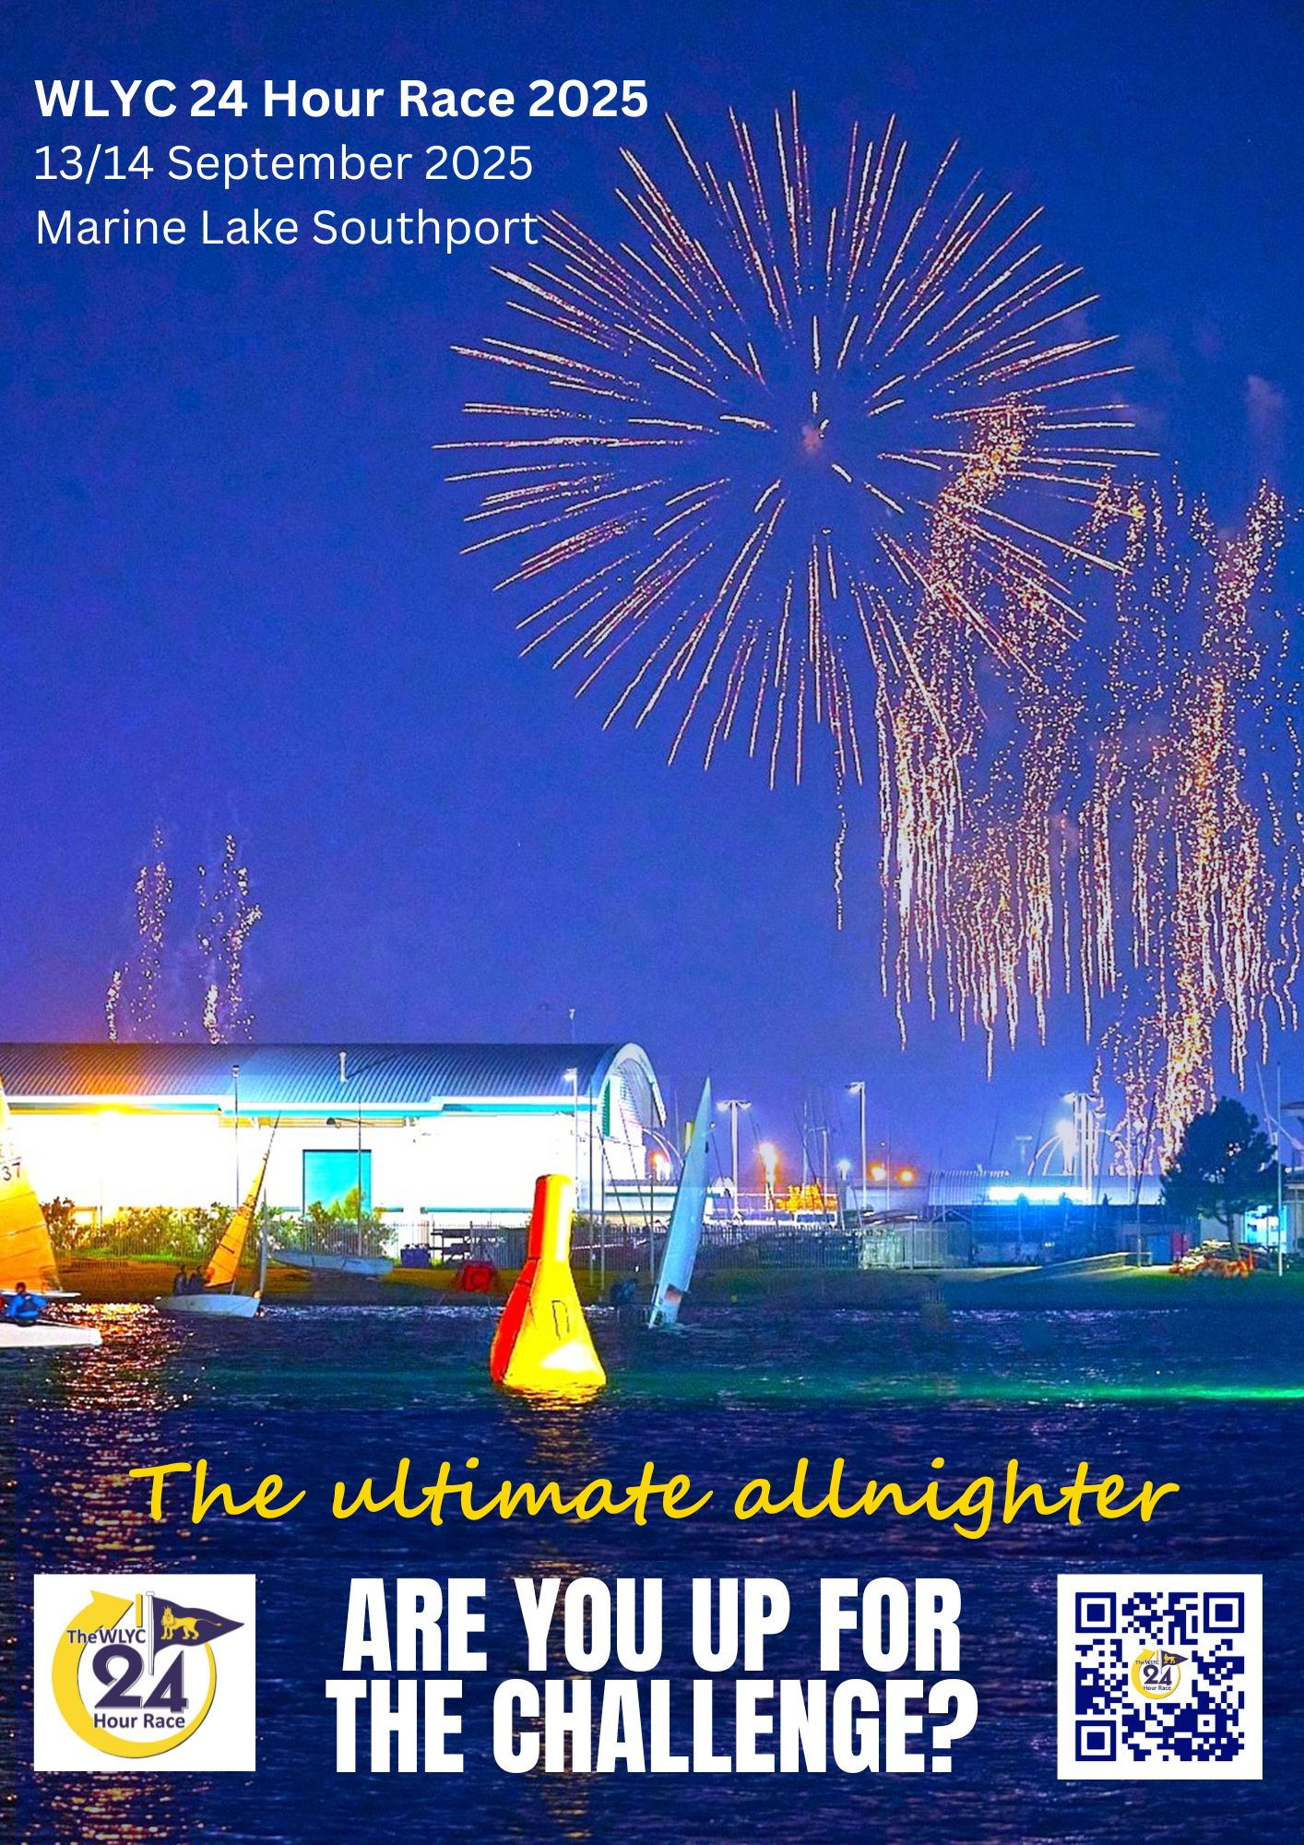

The UK's premier dinghy sailing endurance race – for Fireflies, Enterprises and GP 14s

This magical event came back with a boom in 2024, and entry for this year’s WLYC 24 Hour Race on 13-14 September 2024 is open to Fireflies as well as GP 14s and Enterprises via the GP14 online shop. Will your team be there to help write the new history of sailing’s premier endurance event?

WLYC 24 Hour Race - RYA video

Make sure you join us for the Friday night! It’s one of the best social events in the dinghy racing calendar. Established in 1967, with huge participation from university sailing clubs over the years, the WLYC 24 Hour Race is the best opportunity for club teams to compete for serious trophies and status, whilst also enjoying the unique hospitality and atmosphere.

Entries are accepted from sailing clubs, class associations and universities throughout the UK, with past visits from Eire, France and even the USA. Every generation is represented and national elite sailors contend with local sea cadets and every level in between.

The race is sailed on the relatively safe waters of the Marine Lake in Southport, and racing is continuous for 24 hours even in extreme weather conditions. Crew, equipment and sail changes are permitted during the race in a designated docking area.

Entry: WLYC 24 Hour Race - Enter your team for the 2025 event
Dates: 13-14 September 2024
Location: West Lancashire Yacht Club Marine Drive, Southport, PR8 1RY
Website URL: wlyc.org.uk/
Contact Name: Richard Westlake, Commodore
Email: wlyc24hourrace@gmail.com
Phone: 07739 479840

