LOUGHBOROUGH STUDENTS SAILING AND WINDSURFING CLUB
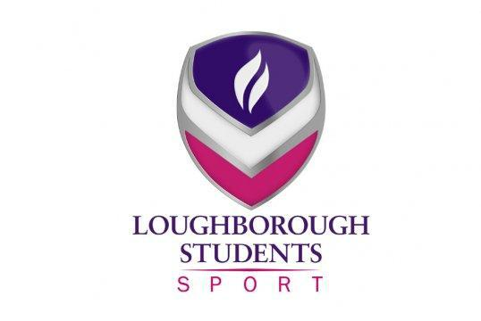

LOUGHBOROUGH LEMMING
5th DECEMBER – 7th DECEMBER 2024
PLAN FOR THE WEEKEND
Friday 5th December
19:00 – Registration at The Blacksmith Arms, LE11 3HB. Collect welcome packs, meet your hosts. Stay for a couple of pints!!! Parking is available at Loughborough Leisure Centre, LE11 3HE.
21:00 – Pres at The Swan In The Rushes, LE11 5BE.
23:30 – FND @ Loughborough Student’s Union, LE11 3TT. The dress code is ‘Starry Night’, so make sure you come wearing your most sparkly outfit!

Saturday 6th December
08:45 – Registration at Burton Sailing Club, DE65 6EG, for teams arriving Saturday morning.
09:00 – Introductions and briefings.
09:27 – First three-minute warning signal.
15:30 – Approximate end of racing.
20:30 – Punch Party! Visiting teams please go to your allocated common room in costume.
23:30 – Echo’s nightclub, LE11 1UA.

Common Room Allocation:
Butler Court – LE11 3TS | Teams:  - UEA Yellow  - UEA Blue  - UEA Green  - Durham White  - Durham Red  - Durham Bubblegum Pink  - Liverpool Pimps  - Liverpool Wenches  - Rambone  - Sheffield Sherry
Towers – LE11 3TG | Teams:  - Newcastle Brown  - Newcastle Blue  - Bath Bubbles  - BPS  - Leeds Green  - Warwick Black  - Nottingham Green  - Nottingham Yellow  - Nottingham White

Sunday 7th December
09:27 – First three-minute warning signal.
13:30 – Approximate end of round robin.
14:30 – Approximate start of Semi-Finals / Finals.
15:30 – Approximate end of racing.
16:00 – Prize Giving.

Saturday costumes:
Bath Bubbles | Angels
BPS | Yetis
Durham Bubblegum Pink | Christmas pudding
Durham Red | The Grinch
Durham White | Wise Men
Leeds Green | Snowflakes
Liverpool Pimps | Shepherds
Liverpool Wenches | Christmas trees
Loughborough Alumni | Santas
Loughborough Freshers | Santas
Newcastle Blue | Penguins
Newcastle Brown | Candy Canes
Newcastle Red | Donkeys
Nottingham Green | Presents
Nottingham White | Reindeers
Nottingham Yellow | Fairy Lights
Rambone | Gingerbread men
Sheffield Sherry | Elves
UEA Blue | Turkeys
UEA Green | Brussel sprouts
UEA Yellow | Tinsel
Warwick Black | Snowmen

Hosts:
Team Name | Host Name | Phone Number | Address
Loughborough Alumni | Lucy  Toby | 07808028816 | 27 Good Yards Close, LE11 5EB  37 Coniston Crescent, LE11 3RQ
Durham White  Durham Red  Durham Bubblegum Pink | Lola | 07835045413 | 133 Station Street, LE11 5EG
UEA Yellow  UEA Blue  Newcastle Brown  Newcastle Blue | Poppy | 07444107245 | 215 Beacon Road, LE11 2QZ
Leeds Green | Zoe | 07759251988 | 26 Arthur Street, LE11 3AY
Warwick Black | Sam | 07512645952 | 8 Arthur Street, LE11 3AY
Liverpool Pimps  Liverpool Wenches | Peter | 07759814465 | 90 Gracedieu Road, LE11 4QG
Bath Bubbles  BPS | Ben S | 07488232926 | 99 Park Road, LE11 2HD
Nottingham Green | Abbey | 07756513994 | 122b Old Ashby Road, LE11 4PQ
UEA Green | Bee | 07716655477 | LL104 – William Morris Halls, LE11 3TQ
Nottingham Yellow | Joe | 07365805222 | B26 – David Collet Hall, LE11 3UE
Nottingham White | Filip | 07575414466 | TT001 - William Morris Halls, LE11 3TQ
Rambone | Ollie | 07437208569 | Block 10 – Cayley Hall, LE11 3TU
Sheffield | Ben T | 07869469820 | A Block – Faraday Hall, LE11 3TY

