

More sailing and more socials and more KLUTE than ever before...

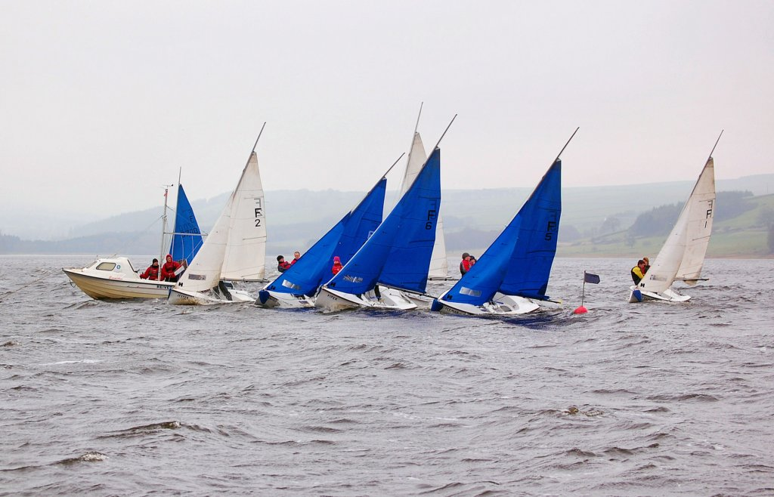
26/27TH November Entry: £210 per team
The Durham Dambuster is back this year with a new (and we think better) format to make sure everyone gets as much time as possible on the water and in the clubs.
So what’s new ?
This year we will be running with a much higher ratio of flights to teams, aiming to have no more than 5 or 6 teams in any league. Entry will be limited to 18 teams and provided we have more than about 12-14 entries we will be running a three flight event.
We hope that this way we will be able to run 3 leagues, followed by gold silver and bronze fleets and then knockouts, or possibly even a complete round robin. This will mean that everyone should get more than 10 races over the weekend and in some cases as many as 15!
What about socials?
Just because we’re planning more sailing doesn’t mean we’re skimping on the socials either. This year we will still making sure everyone gets acquainted with Klute on Friday but are planning to head out for a bar crawl and then a trip to one of Durham’s newer clubs on Saturday evening. A full social programme will be released in October.
We’re also hoping to provide hot food at Derwent Reservoir as part of social tickets, instead of the traditional packed lunch. Because of this, we ask you to book/ social tickets with your entry so we can arrange catering in advance.

Durham Dambuster-Entry Form

Team Name
Club Class or Association
Captain
Contact Address

Postcode
Phone Number
Email

Helms:
1
2
3
4
Crews:
1
2
3
4

Number of social tickets required:

- I wish to enter a team for the Durham Dambuster.
- I enclose a cheque for £210 made payable to Durham University Sailing Club. I also enclose an additional £250 cheque as a damage deposit.
- I agree to be bound by the Racing Rules of Sailing, the Notice of Race and any other rules and regulations that govern this event.

Signed (team captain)

Print Name

Please return this entry form and cheques to Edward Harrison, 19 East Atherton Street, Durham, DH14DG, no later than 5th November 2011. Please remember, your team’s place will not be reserved until both a form and entry fee are received.

