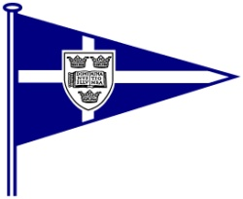
OXFORD UNIVERSITY YACHT CLUB

The Oxford Magnum - 17th / 18th November 2012

Application Form

Team Name:

Helm 1 |  | Crew 1
Helm 2 |  | Crew 2
Helm 3 |  | Crew 3

Team Sailing CV – number of years sailed together, notable achievements etc

`

Team Contact Information

Team Contact ……………………………………………………………………………………

Address ……………………………………………………………………………………

Phone Number ……………………………………………………………………………………

Email address ……………………………………………………………………………………

Please return to oxfordmagnum2012@gmail.com by 15th October at the latest.
Thanks!

Teams will be notified of the success of their application by the 22nd October, and sent an entry form to the e-mail address specified above, which is to be returned, along with a £260 entry fee cheque, a £300 damage deposit cheque and a signed declaration (found on the NoR) by the 5th November to:
Benjamin Rahemtulla, Jesus College, Oxford, Oxon, OX1 3DW

