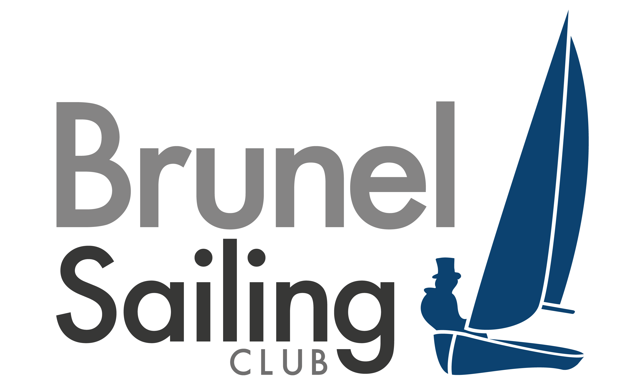
Brunel Badger Entry Form

UNIVERSITY: _________________________________________________________

TEAM (Mixed/Ladies/1st, 2nd): _____________________________________
SAILING CLUB CONTACT NAME: ____________________________________
POSITION IN SAILING CLUB: ____________________________________________________________
CONTACT ADDRESS: ___________________________________________________________________
___________________________________________________________________
CONTACT E-MAIL: ______________________________________________________________________
CONTACT TELEPHONE: _________________________________________________________________
TEAM REGISTRATION:
Captain: _______________________________________ Tel: ______________________________
Helm 1: _______________________________________ Crew 1: ______________________________
Helm 2: _______________________________________ Crew 2: ______________________________
Helm 3: _______________________________________ Crew 3: ______________________________
Reserves: ________________________________________________________________________________
Socials: __________________________________________________________________________________
___________________________________________________________________________________________
___________________________________________________________________________________________
Please list the full name of all possible sailing and social members for this event, as they need to be registered at our Student Union in order to participate in the social events.

Please choose which nights you require accommodation:
Friday Saturday

I have enclosed 2 separate cheques for £200/£180 (delete as appropriate) and £250 made payable to ‘Union of Brunel Students’. The cheque for £200/£180 covers entry and the £250 covers the damage deposit, which will be fully refundable on the condition that no damage is incurred to boats or property. The entry fee includes accommodation.

All members of my team agree to abide by the rules laid out by the Notice of Race, the Sailing Instructions and the decisions of the organising authority.

Signed (Team Captain): ___________________________________ Date: __________________

Please return this form and both cheques to: Saul Parkinson, 1 Nine Elms Close, Uxbridge, Middlesex, UB83TN by 8th February 2013.

