
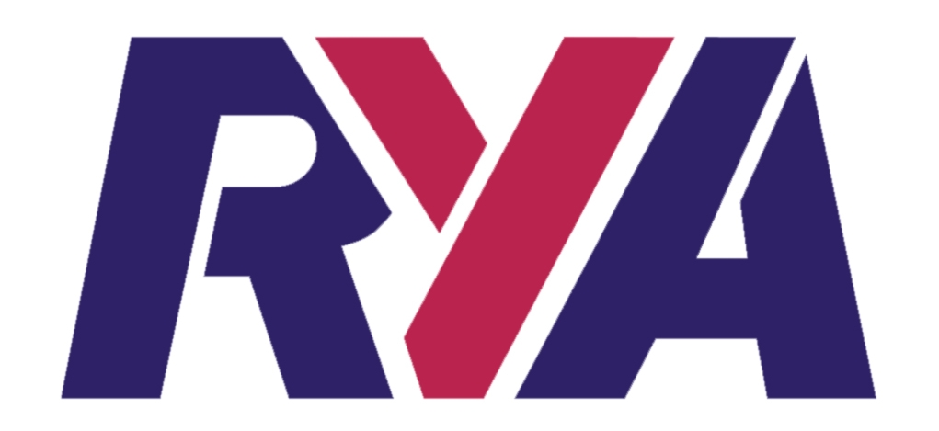
NOTICE OF RACE

RYA NATIONAL TEAM RACING CHAMPIONSHIP 2013
FOR THE PRINCE PHILIP TROPHY

- The RYA National Team Racing Championship 2013, for three boat teams, will take place on 16 and 17 March 2013. The event is open to any team meeting the conditions below.
- The organising authority is West Kirby Sailing Club.
- The championship will be sailed on the Marine Lake in West Kirby, Wirral, in two person Firefly-type dinghies provided by the organising authority.

Event Format
        - Registration will take place from 0830 on the first morning.
        - The format and race schedule will be available at registration.
        - Unless otherwise notified by email to accepted entries not less than seven days before the event, there will be a briefing for all competitors at 0915 on the first morning and the first warning signal will be at 1000.

5 Entry and Eligibility
- Entry is invited from RYA affiliated clubs and class associations and from other organisations affiliated to an organisation that is affiliated to the RYA. However, if fewer than 24 teams have entered by 31 January 2013, the organising authority may accept other entries, but any such entries will not be eligible either to receive the Prince Philip Trophy or to race in any knock-out phase of the event.
- All three helms shall be members of the affiliated club or association they represent.
- No competitor may sail for more than one team. After an entry has been accepted, the nominated helms shall not be changed without the prior written approval of the race committee.
- Entry is limited to 24 teams.
- If more than 24 teams apply for entry by 31 January 2013, teams will be accepted in the following order:
  - Winner RYA National Team Racing Championship 2012 (Spinnaker Auspicious), provided that at least two of the helms are the same.
  - A team representing the host club for this Championship.
  - Winner RYA National Youth Team Racing Championship 2012 (Magdalen Collage School), provided that at least two of the helms are the same.
  - In order of the accumulated scores of the helms, calculated in accordance with Addendum 1 to this notice of race, starting with the team with the highest accumulated score.
  - In order of receipt of entry complete with entry fee.
If any team fails to take up their place, the next placed team will qualify. If there is doubt about the acceptance of any entry, the race committee shall decide. Entries received after 31 January 2013 will be accepted solely in order of receipt.
- Decisions of the race committee about entry or eligibility shall not be cause for redress. This amends rules 62.1 and 63.1.
- All competitors in all teams shall complete the registration requirements before racing.
- All competitors who will be under 18 years of age on 16 March 2013 shall provide at registration a fully completed and signed RYA parent/guardian declaration form.

Entry Fees and Damage Deposits
The entry fee is £250 per team if the entry is received by 31 January 2013, or £280 per team if the entry is received later, payable with the entry form.
Each team will be liable for the cost of damage to boats, equipment and property up to a maximum of £300 per incident. A deposit for this amount is required before the team may sail. When a team is assessed as liable for damage, it shall restore the deposit to the original value in order to continue sailing. Damage attributed to competitors generally or to an unidentified team will be attributed equally between all teams. A team may apply to the protest committee to determine its responsibility for any damage. The deposit, or any remaining balance of the deposit, will be returned after the championship.

Rules
        - Racing will be governed by the rules as defined in the Racing Rules of Sailing (RRS) including appendix D, Team Racing Rules.
        - The UK Team Racing Association Team Racing Sailing Instructions will apply. These change some rules in the RRS; they are available on the UKTRA web site (www.teamracing.org) and at registration.
        - All races will be umpired. The ISAF Call Book for Team Racing will apply.
        - In accordance with rule 70.5(a), the right of appeal will be denied.

Personal Flotation Devices and Clothing
Every competitor shall wear an adequate personal flotation device, and either a drysuit or a "longjohn" wet suit (minimum 3mm thickness), at all times when afloat.

Risk Statement
Rule 4 of the Racing Rules of Sailing states: "The responsibility for a boat’s decision to participate in a race or to continue racing is hers alone."
Sailing is by its nature an unpredictable sport and therefore inherently involves an element of risk. By taking part in the event, each competitor agrees and acknowledges that:
(a) They are aware of the inherent element of risk involved in the sport and accept responsibility for the exposure of themselves, their crew and their boat to such inherent risk whilst taking part in the event;
(b) They are responsible for the safety of themselves, their crew, their boat and their other property whether afloat or ashore;
(c) They accept responsibility for any injury, damage or loss to the extent caused by their own actions or omissions;
(d) Their boat is in good order, equipped to sail in the event and they are fit to participate;
(e) The provision of a race management team, patrol boats and other officials and volunteers by the event organiser does not relieve them of their own responsibilities;
(f) The provision of patrol boat cover is limited to such assistance, particularly in extreme weather conditions, as can be practically provided in the circumstances.

Prizes
The winning team will receive the Prince Philip Trophy which it will hold for one year. Other prizes will be awarded at the discretion of the organising authority.

Entry Forms are available on the UKTRA website (www.teamracing.org) or can be obtained by emailing entries@teamracing.org
NOTICE OF RACE : ADDENDUM 1

CALCULATION OF SCORES

Principles
First, events must participate and complete a simple return to UKTRA with their results.
Second, most events within the time limits and with a minimum of 6 teams may be scored.
Third, scores will be awarded to individual helms, not to teams.

Scoring Events
Any team racing event that takes place within Great Britain with a minimum of 6 competing teams may be scored, subject to the following:
- The event must be sailed between 1 February 2012 and 31 January 2013. An event may be scored provided any part of it falls within this period.
- Keelboat, 2-boat team, random pairs and invitation only events may be scored.
- School and other youth and junior events restricted by age will not be scored except for
BSDRA National Championship
NSSA National Championship
RYA National Youth and Junior Team Racing Championships
- BUSA qualifiers may be scored but not any subsequent play-offs.
- When one event is sailed simultaneously within another, only the larger event may be scored.

Grading Events
Events will be graded primarily by the number of competing teams. Teams that have entered but do not compete will not be counted.
Grade 1 16 or more teams, generally at least two days with a minimum of 3 flights of boats
Grade 2 11 to 15 teams, generally a two day event with 2 or 3 flights of boats
Grade 3 6 to 10 teams, generally a one day event

Scoring Helms
Helms will be scored in accordance with the following table.
Event Grade | Competing Teams | SCORES
Event Grade | Competing Teams | First | Second | Third | Fourth | Fifth | Sixth
1 | 16 or more | 100 | 80 | 60 | 40 | 30 | 20
2 | 11 to 15 | 80 | 60 | 40 | 30 | 20
3 | 6 to 10 | 50 | 30 | 20
Note: the scale is based on a minimum of 20 for any event. If there is bias, it is intentionally in favour of the smaller event to encourage these to participate. As a convenience for sharing scores, all are even numbers.

Each helm may count only his or her best four scores. When there is a tie, the scores for the tied positions will be shared equally. For example, losing semi-finalists when there is no petit-final will share scores for 3rd and 4th places.

The overall results of the Wilson Trophy and any other event including non-GBR teams will be adjusted to remove the non-GBR teams before calculating scores. A non-GBR team is one representing an organisation based outside Great Britain. There are no qualification requirements for competitors in a GBR team.

ENTRY FORM

RYA NATIONAL TEAM RACING CHAMPIONSHIPS 2013
FOR THE PRINCE PHILIP TROPHY

I wish to enter team(s) for the RYA National Team Racing Championships 2013.

I enclose a cheque made payable to UKTRA for £ (£250 per team if entry received by 31 January 2013; £280 per team if entry received later) together with an additional cheque(s) made payable to UKTRA for £300 (being the damage deposit per team).

Please fill in the details below for each team and, if possible, include on the reverse side the best four scores for each helm (see Addendum 1).

Club, class or association
Team Name
Team contact
Contact Address
Email

Phone | home / mobile
Team helms | 1  2  3

All communication following receipt of this entry will be by email. You must ensure the email addresses given above are monitored regularly.

Signed :

Date :

Entry forms should be returned to
Richard Thompson, Manor Farm Cottage, Fairford, Gloucestershire GL7 4AR
together with separate cheques for the entry fee and damage deposit, both payable to UKTRA.

For further details please email entries@teamracing.org
RYA NATIONAL TEAM RACING CHAMPIONSHIP 2013

CALCULATION OF SCORES

Please complete the table below with the 4 best scores that each helm has achieved for events between 1 February 2012 and 31 January 2013. Please see Notice of Race Addendum 1 for details.
If relevant, you will be asked immediately after 31 January 2013 for any scores not included here.

Helm | Event & Dates | Entries | Team Name | Place | Score

The entry fee includes breakfast & packed lunch for both days and supper on Saturday evening for all competitors.
Full details of the fees are at item 6 in the notice of race

