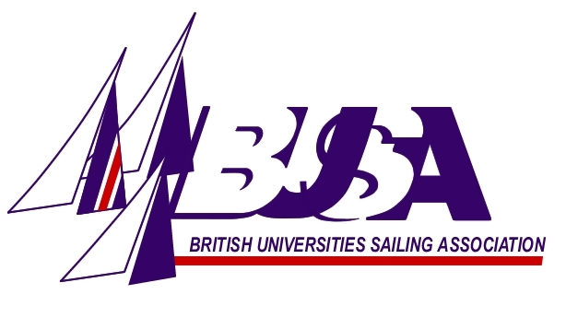
BUSA Wilson Team 2013
Application Form

Name:
Phone no.:
E-mail address:
University and Team (colour):
Helm/Crew/Both:
Weight in Kgs:
Team racing experience:

(including any other relevant experience)

Please return forms to: Phil Derry
Holywell Manor
Manor Road
Oxford, OX1 3UH

AND/OR e-mail them to: philip.derry@chem.ox.ac.uk

THE DEADLINE FOR RECEIPT OF APPLICATION FORMS IS
22ND MARCH 2013

