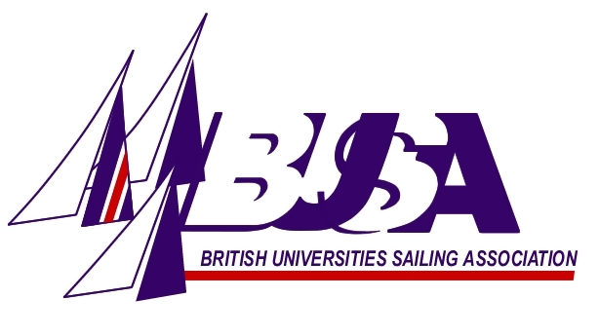
BUSA Tour 2013
Application Form

Name:
Phone no.:
E-mail address:
University and Team (colour):
Matches applied for:
Team racing experience:

(including any other experience relevant to specific matches)
Match racing experience:

Please indicate here if you will be unavailable for any period from 8th – 29th July 2013:

Please return forms to: Phil Derry
Holywell Manor
Manor Road
Oxford, OX1 3UH

AND/OR e-mail them to: philip.derry@chem.ox.ac.uk

THE DEALINE FOR RECEIPT OF APPLICATION FORMS IS 1ST APRIL 2013

