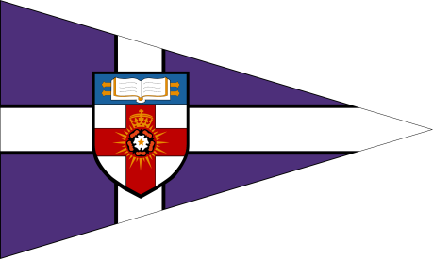
The University of London Sailing Club

The London 6 - Pack
Saturday 23rd – Sunday 24th November 2013

ENTRY FORM

- I wish to enter a team for the London Duck.
- I enclose a cheque for £250 made payable to ‘The University of London Sailing Club’, together with an additional cheque for £250 to cover the damage deposit.
- I agree to be bound by the Racing Rules of Sailing and all other rules that govern this event.
Details:

Team Name
Club Class or Association
Team Captain
Contact Address
Postcode
Phone Number
Email

Team:
Helms:  1.  2.  3. | Crews:  1.  2.  3.
Number of people attending social:
Number of sailors requiring accommodation:

Please return completed entry forms and cheques (made payable to ‘The University of London Sailing Club’) by Wednesday 6th November 2013 to:

Lisa McDannell, 86 Ladbroke Grove, London W11 2HE

Signed (team captain) _________________________ Date_______________________

