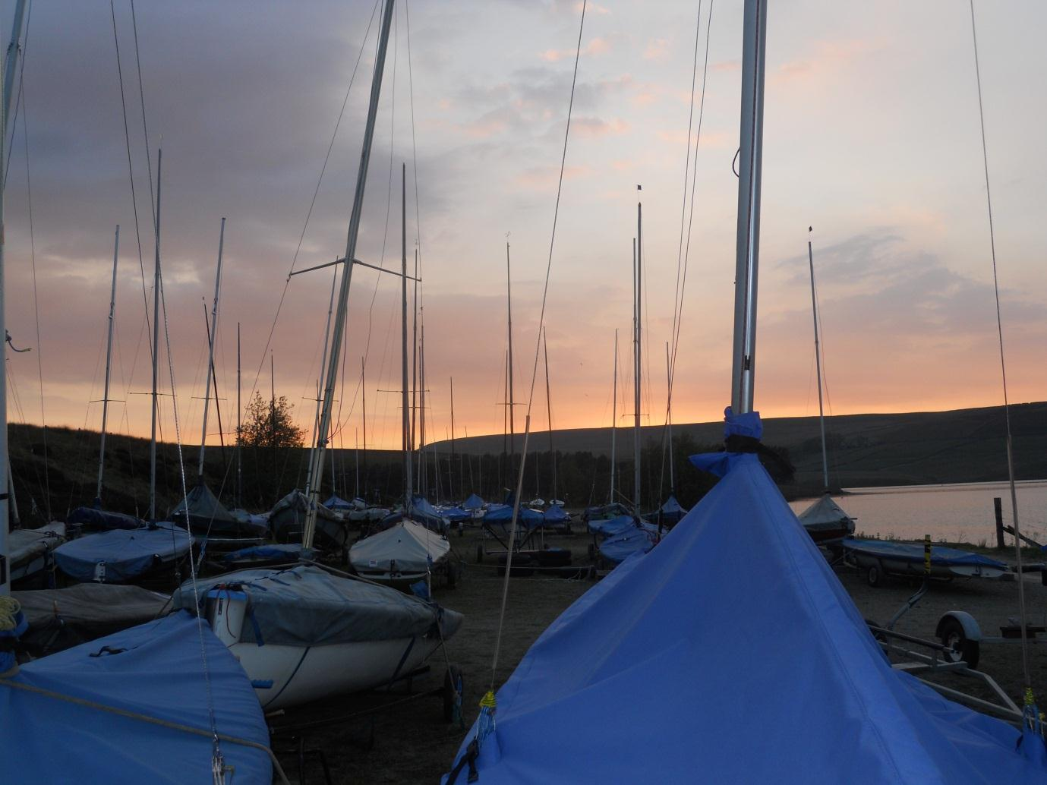The SHEFFIELD SHUFFLE 2013  
The University of Sheffield Sailing Club

Entry Form

Team Captain Details

Name and University:

Mobile Number:

Address:

Team

Name:

Name:

Name:

Name:

Name:

Name:

The entry fee is **£250** per team and the damage deposit is **£250**. Please make your cheques payable to Sheffield University Sailing Club and send them to: Amy Bower, 65 Pickmere Road, Crookes, Sheffield, S10 1GZ.

Please note that entry is not confirmed until we have received your form and cheque.

Social tickets will cost **£10** per person and include entry to nightclubs on Friday and Saturday, as well as 2 hot lunches over the weekend. They can be bought when you arrive here!  
We look forward to seeing you at the Sheffield Shuffle!

We now have 6 fireflies and would be more than willing to lend them for use at team racing events!