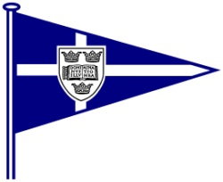OXFORD UNIVERSITY YACHT CLUB

The Oxford Magnum - 29th / 30th November 2014

**Application Form**

**Team Name:**

|  |  |  |  |
| --- | --- | --- | --- |
| **Helm 1** |  | **Crew 1** |  |
| **Helm 2** |  | **Crew 2** |  |
| **Helm 3** |  | **Crew 3** |  |

**Team Sailing CV – number of years sailed together, notable achievements etc**

**`**

**Team Contact Information**

Team Contact ……………………………………………………………………………………

Address ……………………………………………………………………………………

Phone Number ……………………………………………………………………………………

Email address ……………………………………………………………………………………

*Please return to* [*fixtures@ouyc.co.uk*](mailto:fixtures@ouyc.co.uk) *by 12th October at the latest.*

*Thanks!*

Teams will be notified of the success of their application by the **19th October**, and sent an entry form to the e-mail address specified above, which is to be returned, along with a the entry fee cheque, a £300 damage deposit cheque and a signed declaration (found on the NoR) by the **16th November** to:

Meli Besse, Worcester College, Oxford, OX1 2HB