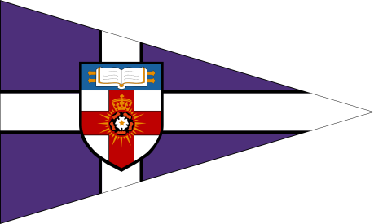
The University of London Sailing Club

The London 6 - Pack
Saturday 22nd – Sunday 23rd November 2014

ENTRY FORM

- I wish to enter a team for the London Duck.
- I enclose a cheque for £250 made payable to ‘The University of London’, together with an additional cheque for £250 to cover the damage deposit.
- I agree to be bound by the Racing Rules of Sailing and all other rules that govern this event.
Details:

Team Name
Club Class or Association
Team Captain
Contact Address
Postcode
Phone Number
Email

Team:
Helms:  1.  2.  3. | Crews:  1.  2.  3.
Number of people attending social:
Number of sailors requiring accommodation:

Please return completed entry forms and cheques (made payable to ‘The University of London’) by Wednesday 12th November 2014 to:

Alison Norbury, 9a Oxford and Cambridge Mansions, Transept Street, London, NW1 5EJ

Signed (team captain) _________________________ Date_______________________

