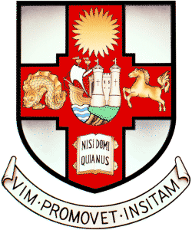

Team Name

Captain

Helm 1 |  | Crew 1
Helm 2 |  | Crew 2
Helm 3 |  | Crew 3

Please provide the telephone numbers and email addresses of the Captain and one other member of the team below. These should be telephone numbers that we can reach you on during the event.

Name of Captain

Telephone number

Email address

Name of Team Member

Telephone number

Email address

Please give an indication of how many team members require accommodation on Saturday night and how many will want social tickets.

Number requiring accommodation

Number of social tickets

Checklist:
- £300 entry fee, £200 damage deposit (both payable to University of Bristol Sailing Club).
- Completed entry form.
- Signed declaration (on Notice of Race).

Please return the above by Monday 3rd November 2014 to:

Lucy Hartley, 15 Highbury Villas, Kingsdown, Bristol, BS2 8BX

Any queries please get in touch!
Email: lh12945@my.bristol.ac.uk / Tel: 07722849988

