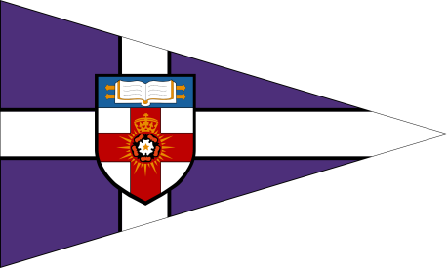
The University of London Sailing Club

The London Duck
Saturday 7th – Sunday 8th March 2015

ENTRY FORM

- I wish to enter a team for the London Duck.
- I enclose a cheque for £250 (or £150 for discounted teams) made payable to ‘The University of London’, together with an additional cheque for £250 to cover the damage deposit.
- I agree to be bound by the Racing Rules of Sailing and all other rules that govern this event.
Details:

Team Name
Club Class or Association
Team Captain
Contact Address
Postcode
Phone Number
Email

Team:
Helms:  1.  2.  3. | Crews:  1.  2.  3.
Number of sailors attending social:
Number of sailors requiring accommodation:

Please return completed entry forms and cheques (made payable to ‘The University of London Sailing Club’) by Sunday 15th February 2015 to:

Amy Sanderson, Flat 7 Grangefield, Marquis Road, London, NW1 9UA

Signed (team captain) _________________________ Date_______________________

