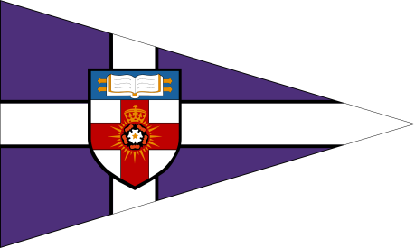
The University of London Sailing Club

The London Duck
Saturday 21st – Sunday 22nd November 2015

ENTRY FORM

- I wish to enter a team for the London Duck.
- I enclose a cheque for £260 made payable to ‘University of London’, together with an additional cheque for £250 to cover the damage deposit.
- I agree to be bound by the Racing Rules of Sailing and all other rules that govern this event.
Details:

Team Name
Club Class or Association
Team Captain
Contact Address
Postcode
Phone Number
Email

Team:
Helms:  1.  2.  3. | Crews:  1.  2.  3.
Number of sailors attending social:
Number of sailors requiring accommodation:

Please return completed entry forms and cheques (made payable to ‘University of London’) by Monday 9th November 2015 to:

Raphaela Lealan Gracie, University of London Sailing Club, Student Central, Malet Street, London, WC1E 7HY

Signed (team captain) _________________________ Date_______________________

